Here are some helpful links to help you get started using Schoology.
- Create a new parent account at www.schoology.com, using a Parent Access Code provided.
- If you already have a Schoology account because your child attends another school which uses Schoology, please enter a username, instead of your email, when creating an account for St. Isidore School. An example could be your first initial and last name, mdurkee, or your first and last name together, melissadurkee. Next go to Settings:
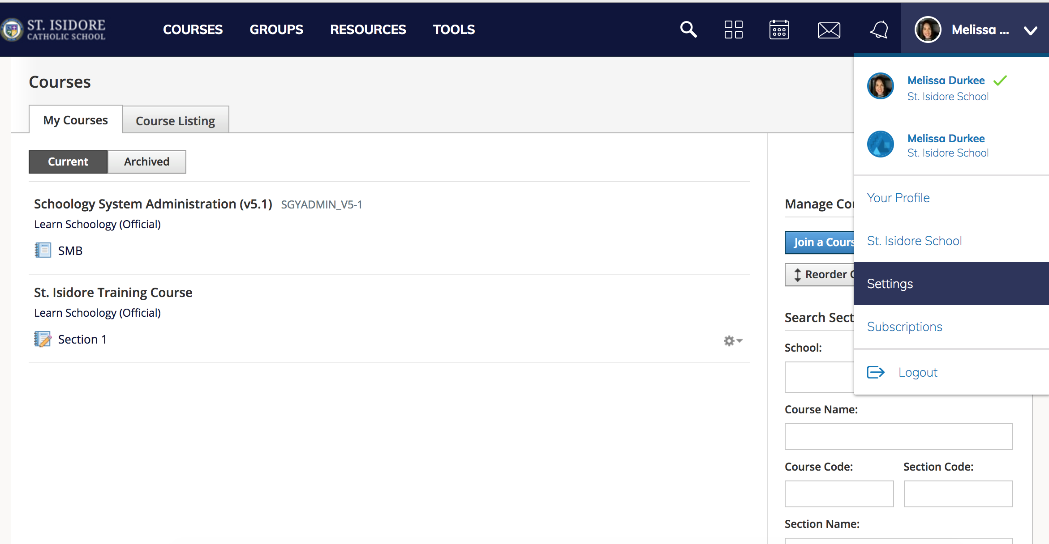
Scroll down to Link Accounts and click on it:
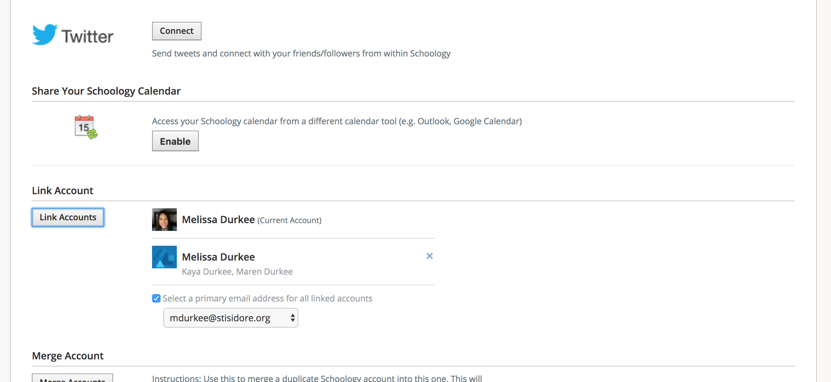

Enter your previous Schoology Account email and password.
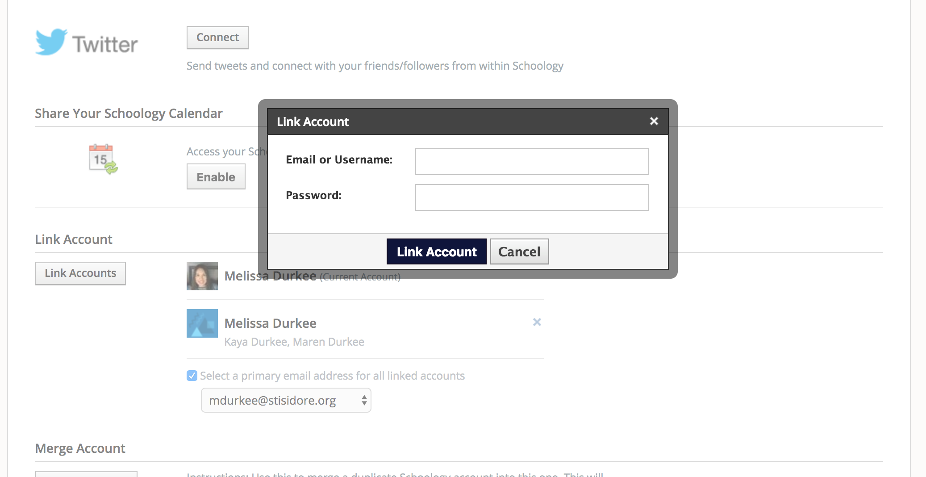
Go Back up to the arrow that points downward in top right corner of screen and you can toggle between your two schools/accounts.
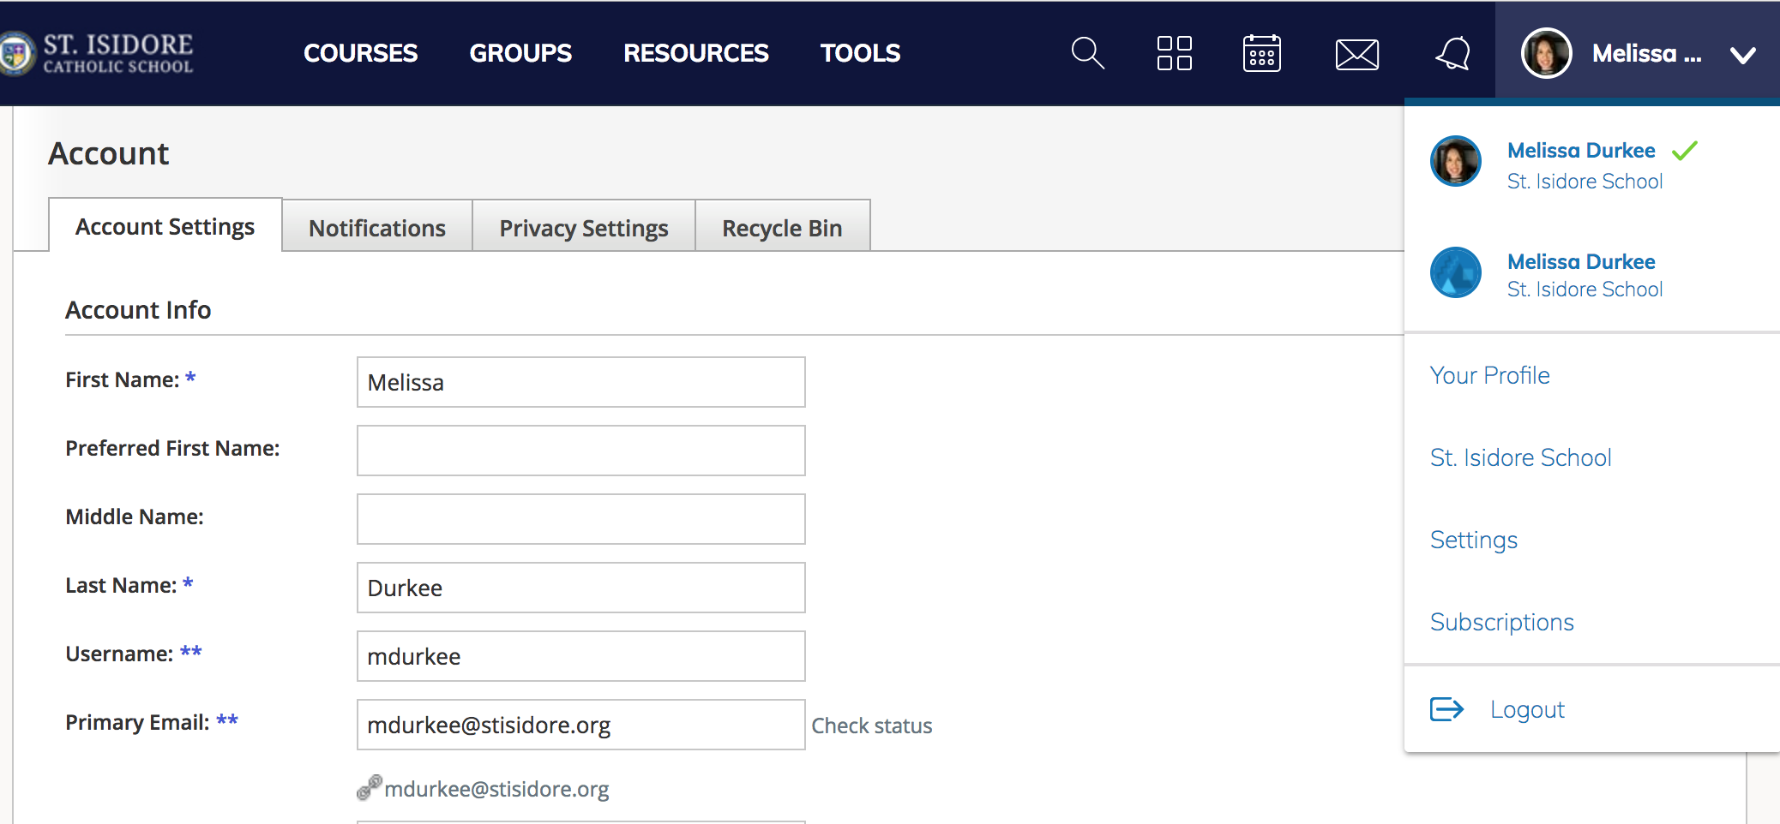
- Compare your parent account to your child's account, https://support.schoology.com/hc/en-us/articles/201000833-Home-Page-Parents-, to get an understanding of how Schoology works for you and for your child.
- Add multiple children to your Schoology account, so you can access all of your children's information from one location.
- Log in to your Schoology account using your username or email address and password.
- Click the arrow next to your name in the top-right corner.
- Click the Add Child button.
- Enter the Child Code for the child you're adding. This is the same as your Parent Access Code, the 12-digit code in xxxx-xxxx-xxxx format that you receive from one of your child's instructors.
- Click the Use Code button to complete.
- The Parents' Guide To Schoology, https://support.schoology.com/hc/en-us/articles/201000873-Parent-Guide, provides a detailed explanation of how to use multiple features within Schoology.
- To join the SIS Parent Group and your prospective Class Parent Groups, ie: Gr 1 Hutchinson Parent Group using the access codes below, please ensure you are in the parent view. The groups will be where parents will receive updates from the school, teachers, and room parents. Updates from the teachers to students will be in their courses.
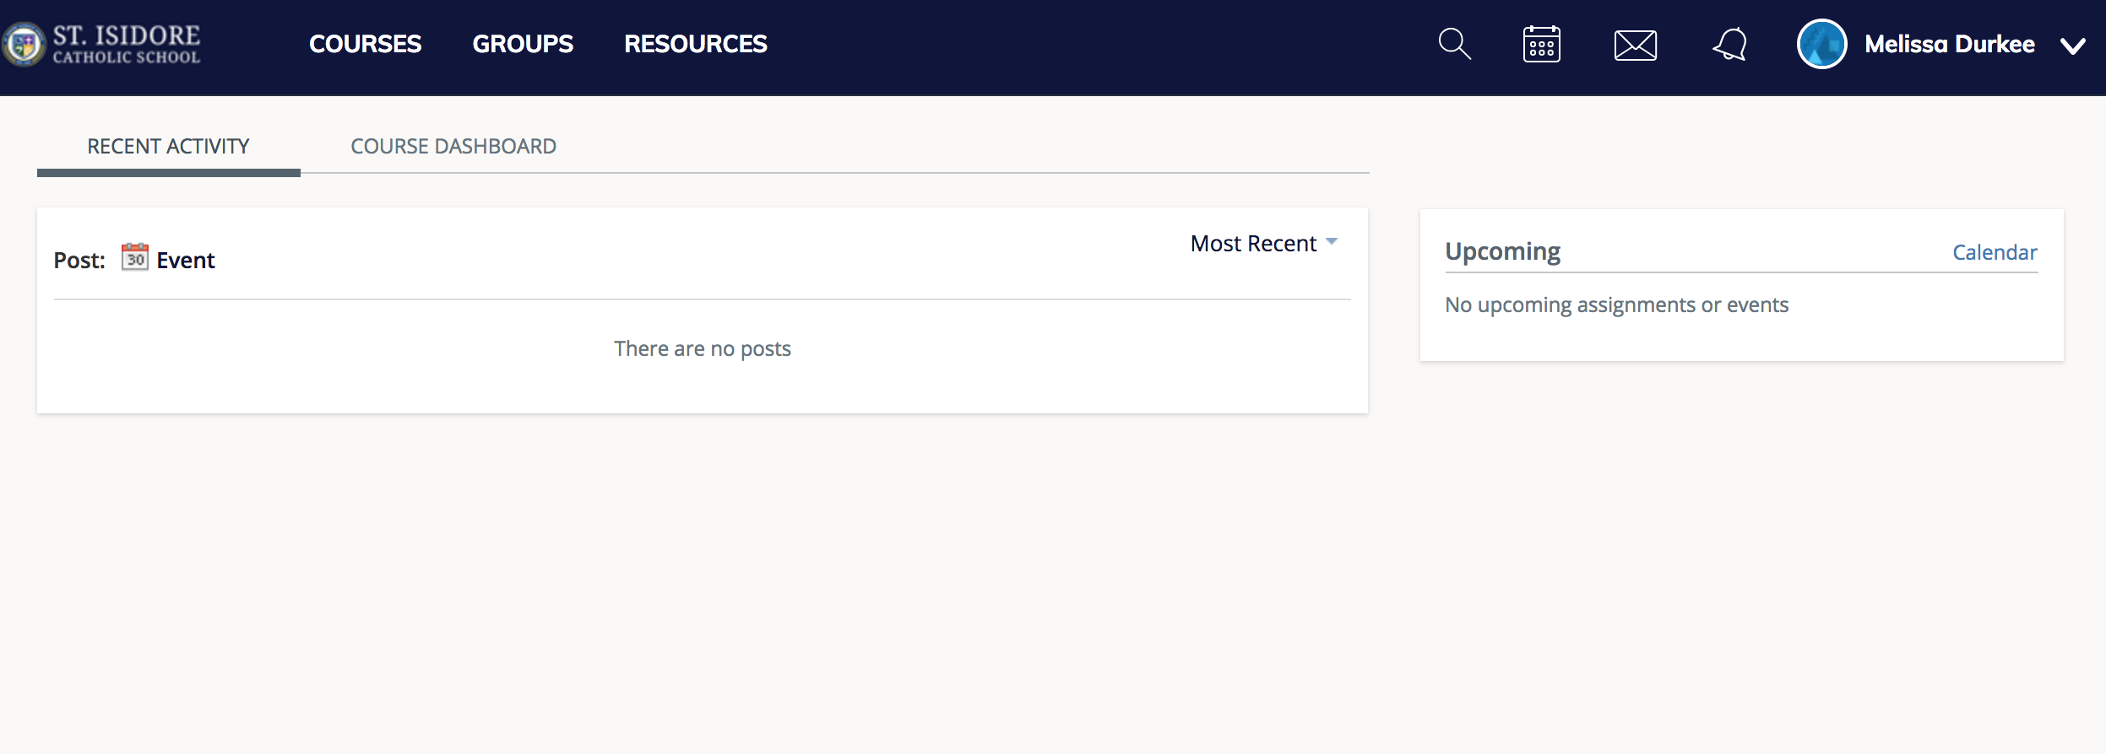

Click on Groups, then click on Join a Group, repeat steps for joining a group.
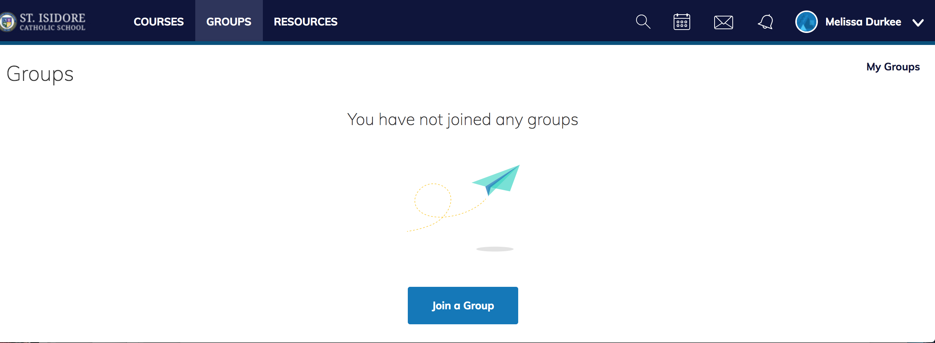

Enter Access Code from below list, then click Join.

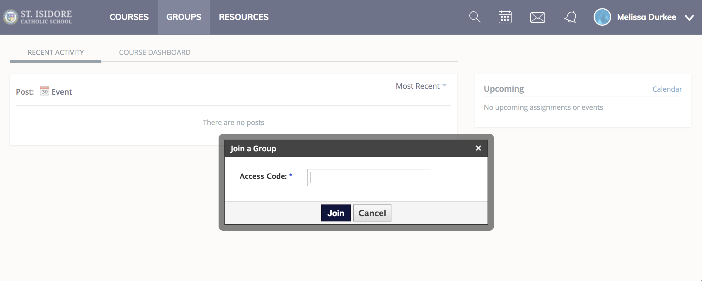

SIS Parent Group: CF3GC-D376C
TK – Willms Parent Group: H6T9T-XJX6S
K – Esposito Parent Group: QTRZG-WKFTZ
K – Sullivan Parent Group: D62D8-QSRM7
K – Boyle Parent Group: CGZXQ-7QK3J
Gr 1 – Hutchinson Parent Group: S7DMG-KD5VC
Gr 1 – Devine Parent Group: V2D7B-ZVNBM
Gr 2 – Landy Parent Group: R456B-TZRRD
Gr 2 – Bobich Parent Group: SKWW4-2K9VR
Gr 3 – Goetze Parent Group: D35S3-DK6W9
Gr 3 – Gerberich Parent Group: 2734B-H74TR
Gr 4 – Trujillo Parent Group: MZCNP-S9TV6
Gr 4 – Johnson Parent Group: 4KFJ8-X9Q36
Gr 5 – Donnelly Parent Group: F8MTT-WB8ZH
Gr 5 – Lettire Parent Group: 8NFVB-DJ9J9
Gr 6 – Williamson Parent Group: SZR6R-7RDMW
Gr 6 – Wissinger Parent Group: MWGBN-MBW9N
Gr 7 – Lettire Parent Group: 6R9M5-KTD2H
Gr 7 – Miller/Joseph Parent Group: 57ZBF-35BBB
Gr 8 – Carter Parent Group: PG6WQ-TC3NM
Gr 8 – Torretta Parent Group: D7D9P-993KN

