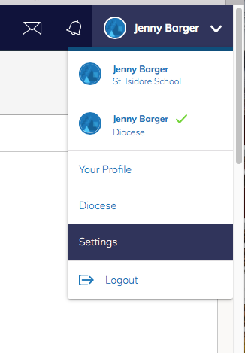
Go to your account in the top right corner. Hit drop down and select “Settings.”

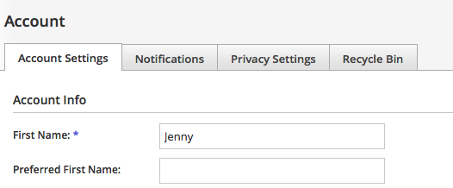
Select NotificaticationTab

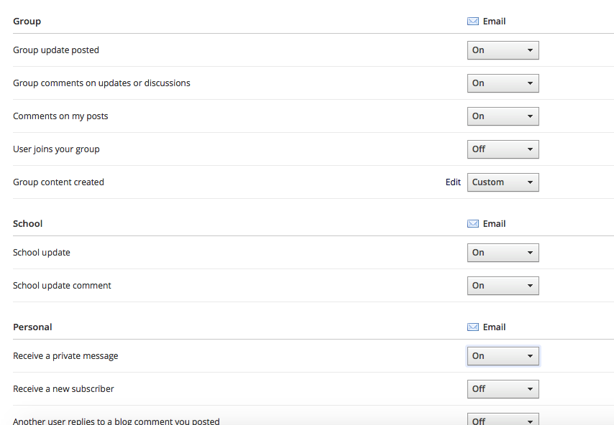
Make Sure your GROUP and SCHOOL
Notifications are turned on.

