The CLUB is coordinating a trip to Nashville…
The Public is invited to join them…

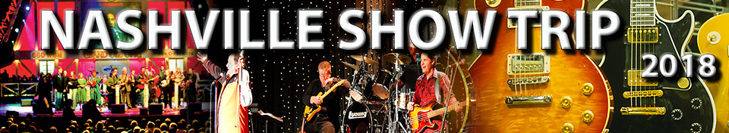

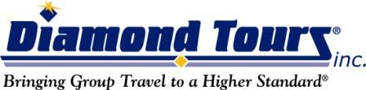
Nashville Show Trip
- 3 Days - 2 Nights
- Jul 30 - Aug 01, 2018
- $365 pp/Double Occupancy

This Tour Includes:
- Motor coach transportation
- 2 nights lodging
- 4 meals: 2 breakfasts and 2 dinners
- Guided Tour of NASHVILLE
- Admission to the GRAND OLE OPRY BEHIND THE SCENES TOUR
- Visit to Opry Mills
- 2 Great Shows: 1) THE GRAND OLE OPRY
2) NASHVILLE NIGHTLIFE DINNER THEATER
- Ride on the DELTA FLATBOATS inside the OPRYLAND HOTEL

For Information & Reservations Contact:
Fran Davis @ (256)760-6642
The Club @ (256) 760-6420
You can also email me at franfish@comcast.net

Departure:
The Club, 450 Country Club Dr, Florence, AL @ 8 am

Additional Payment Information:
$75 Due Upon Signing. *Price per person, based on double occupancy. Add $89 for single occupancy. Final Payment Due: 5/23/2018

Click here for Itinerary and Full Details:
http://www.grouptrips.com/TheClub/1446553

