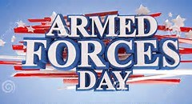
Armed Forces Day Celebration
Saturday, May 20, 2017
9:00 a.m. – 10:15 a.m. (Doors open 8:30)
Good Shepherd Lutheran Church
2001 Cloyd Boulevard (at Darby Drive), Florence, AL
ALL Current & Past Veterans & Families are invited.
This is a “Thank You!” — not a fund-raiser.
Free Continental Breakfast
Support Information for Veterans and Families
Featured Speaker
Numerous Door Prizes

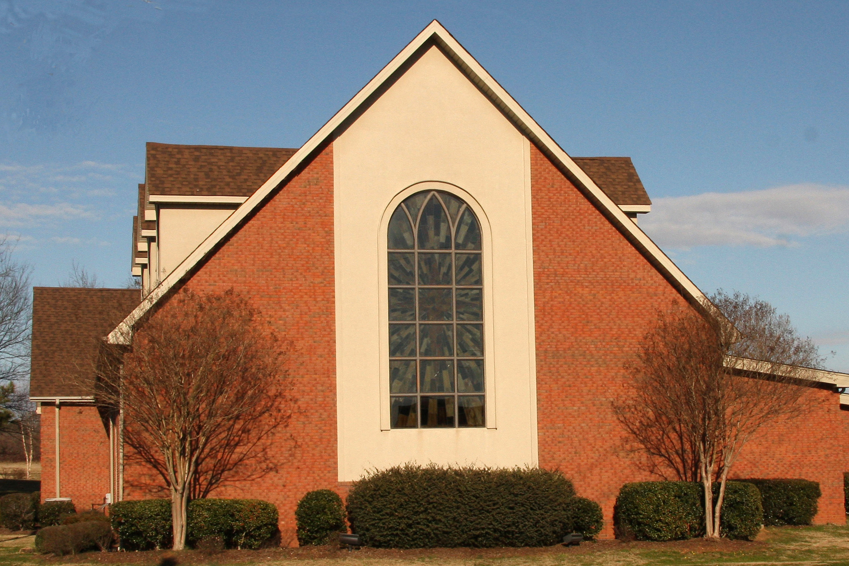 | 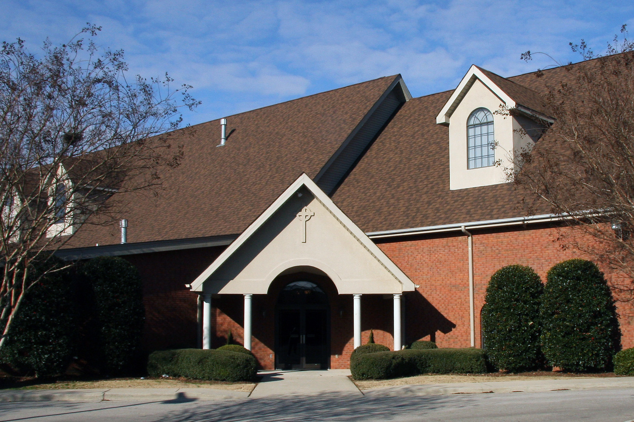
There’s ample parking in Good Shepherd’s lot off Cloyd Boulevard.
Enter through the Portico.
Veterans Groups in Support
American Legion, Post #11, Florence
Korean War Veterans Association, Muscle Shoals
Veterans of Foreign Wars, Post #5140, Florence
We’d like a rough idea of how many are coming.
Please call (256) 766-6952 and leave a message.
It’s OK to come — even if you haven’t told us beforehand.
ALL Veterans and their Families are invited.
Celebrating Armed Forces Day
Each May, from the second Saturday through the Sunday after the third Saturday, we celebrate Armed Forces Week.
The third Saturday, May 20, 2017, is Armed Forces Day. It’s a day to celebrate our Armed Forces with parades, festivities, open houses, receptions, air shows, and the like.
Good Shepherd Lutheran Church, 2001 Cloyd Boulevard at Darby Drive in Florence, wants to show its appreciation for our Armed Forces, by starting off Armed Forces Day with a free continental breakfast beginning 9:00 a.m. and ending 10:15-ish. Doors will open at 8:30.
All Active Duty, Guard, Reserve, and Prior Service members — and their families — are invited.
Three veterans groups will be there to explain their support for veterans and their families:
American Legion Post #11, Florence
Korean War Veterans Association, Muscle Shoals
for those who served in Korea
Veterans of Foreign Wars Post #5140, Florence
Speaker is Reverend and Naval Reserve Chaplain James Storie, who was activated to provide bereavement counseling for families of the four Marines gunned down July 16, 2015, in Chattanooga, Tennessee. He will deliver a short message for military families, with time for questions after.
For additional information, call Good Shepherd Lutheran Church at
256-766-6952.

Armed Forces Day
Armed Forces Day is a day to pay tribute to the men and women who serve the United States Armed Forces. It is celebrated on the third Saturday in May, as a part of Armed Forces Week, which runs from the second Saturday through Sunday following the third Saturday.
President Harry S. Truman led efforts to establish a single holiday for citizens to come together and thank our military members for their patriotic service in support of our country, replacing several one-day celebrations that existed for each branch. The action stemmed from the 1948 unification of our Armed Forces under our Department of Defense.
The first Armed Forces Day took place on May 20, 1950, having been announced on August 31, 1949, by Secretary of Defense Louis Johnson to replace separate Army, Navy, Marine Corps, U.S. Coast Guard, and Air Force Days.
President John F. Kennedy established Armed Forces Day as an official holiday in 1962.
Armed Forces Week is a time for parades, open houses, receptions, and air shows. Guard and Reserve units, due to their training schedules, may celebrate on different dates in May.
Armed Forces Day May 20, 2017 Celebrates ALL who ARE serving, with
3rd Saturday thanks to those who have served:
Active Duty, Guard, Reserves.
Memorial Day May 29, 2017 Remembers those who DIED in service
Last Monday to the United States of America.
Veterans Day November 11 Remembers ALL who serve or served.

Veterans Day
November 11 was originally known as Armistice Day or Remembrance Day to commemorate the end of World War I on the 11th hour of the 11th day of the 11th month, 1918, and is still called that in other countries.
In 1919, President Woodrow Wilson issued a message, expressing the meaning of the day to Americans:
ADDRESS TO FELLOW-COUNTRYMEN
The White House, November 11, 1919.
“A year ago today our enemies laid down their arms in accordance with an armistice which rendered them impotent to renew hostilities, and gave to the world an assured opportunity to reconstruct its shattered order and to work out in peace a new and juster set of international relations.
The soldiers and people of the European Allies had fought and endured for more than four years to uphold the barrier of civilization against the aggressions of armed force.
We ourselves had been in the conflict something more than a year and a half. - With splendid forgetfulness of mere personal concerns, we re modeled our industries, concentrated our financial resources, increased our agricultural output, and assembled a great army, so that at the last our power was a decisive factor in the victory.
We were able to bring the vast resources, material and moral, of a great and free people to the assistance of our associates in Europe who had suffered and sacrificed without limit in the cause for which we fought. Out of this victory there arose new possibilities of political freedom and economic concert.
The war showed us the strength of great nations acting together for high purposes, and the victory of arms foretells the enduring conquests which can be made in peace when nations act justly and in furtherance of the common interests of men.
To us in America the reflections of Armistice Day will be filled with - solemn pride in the heroism of those who died in the country’s service, and with gratitude for the victory, both because of the thing from which it has freed us and because of the opportunity it has given America to show her sympathy with peace and justice in the councils of nations.”
WOODROW WILSON [1]
Congress adopted a resolution on June 4, 1926, asking President Calvin Coolidge to issue an annual proclamation for the observance of November 11 with appropriate ceremonies.[1] This became an annual tradition.
A Congressional Act (52 Stat. 351; 5 U.S. Code, Sec. 87a) approved May 13, 1938, made November 11 each year a legal holiday, “to be dedicated to the cause of world peace and to be therefore celebrated and known as Armistice Day.”[2]
In 1945, World War II veteran Raymond Weeks from Birmingham, Alabama, had the idea to expand Armistice Day to celebrate all veterans, not just those who died in World War I. He led a delegation to Gen. Dwight D. Eisenhower, who supported the idea of National Veterans Day. Weeks led the first national celebration in 1947 in Alabama and annually until his death in 1985.
U.S. Representative Ed Rees from Emporia, Kansas, presented a bill establishing the holiday through Congress. President Dwight D. Eisenhower, also from Kansas, signed the bill into law on May 26, 1954. It had been eight and a half years since Weeks held his first Armistice Day celebration for all veterans. [3]
Congress amended the bill on June 1, 1954, replacing "Armistice" with "Veterans," and it has been known as Veterans Day since. [4]

Elizabeth Dole, who prepared the briefing for President Reagan, determined Weeks as the “Father of Veterans Day.”
The National Veterans Award was also created in 1954. Congressman Rees of Kansas received the first National Veterans Award in Birmingham, Alabama for his support offering legislation to make Veterans Day a federal holiday.

Although originally scheduled for celebration on November 11 of every year, starting in 1971 through1977 in accordance with the Uniform Monday Holiday Act, Veterans Day was moved to the fourth Monday of October. In 1978, it was moved back to its original celebration on November 11. While the legal holiday remains on November 11, if that date happens to be on a Saturday or Sunday, then organizations that formally observe the holiday will normally be closed on the adjacent Friday or Monday, respectively.
Apostrophes are often incorrectly used in the name. The U.S. Department of Veterans Affairs web site states no apostrophe is to be used “because it is not a day that ‘belongs’ to veterans, it is a day for honoring all veterans.” [5]
1. “Supplement to the Messages and Papers of the Presidents: Covering the Second Term of Woodrow Wilson, March 4, 1917, to March 4, 1921.” Bureau of National Literature. 11 November 2015.
2. “Veterans Day History.” Veteran's Affairs. Retrieved November 12, 2013.
3. Carter, Julie (November 2003). “Where Veterans Day began.” VFW Magazine. Veterans of Foreign Wars of the United States. Archived from the original on 2012-07-14.
4. “History of Veterans Day.” United States Department of Veterans Affairs. 2007-11-26. Retrieved 2008-11-06.
5. “Veterans Day Frequently Asked Questions” (http://www.va.gov/opa/vetsday/vetday_faq.asp), U.S. Office of Public Affairs.

