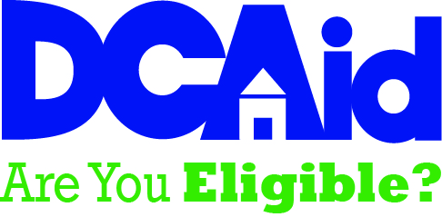
This site will allow you to go through a screening process to see if you are eligible for the NJ Assistance Programs listed below. To begin the screening process click on Get Started!

Screening Process

Check to see what benefits you may qualify for:
Screening takes about 1-2 minutes to complete, and you will need to provide income information.
Get Started!

Assistance Programs Provided By New Jersey
DCA has a variety of programs that can help you with rent/heating costs, prevention of eviction, reduction of utility bills, and removal of lead hazards from your home.

Rental Assistance

Section 8: Housing Choice Voucher Program (HCV)
Helps low-income families pay rent through a Housing Choice Voucher.
State Rental Assistance Program (SRAP)
Helps low-income families pay rent through a State-funded voucher.
Housing Opportunities for People with AIDS (HOPWA)
Helps low-income individuals diagnosed with AIDS pay rent through a voucher.
Veterans Affairs Supportive Housing (VASH)
Helps armed service veterans pay rent with a voucher.

Homelessness and Eviction Prevention
Homeless Prevention Program (HPP)
Offers help to people facing eviction through payment of back rent.
Homeless Prevention and Rapid Re-Housing Program (HPRP)
Offers relocation and temporary rental assistance to low income families.

Home Energy Assistance
Low Income Home Energy Assistance Program (LIHEAP)/Universal Service Fund (USF)
Helps low-income residents with their heating/cooling bills, offers emergency heating system repair and emergency fuel assistance.

Other Programs
Weatherization Assistance Program (WAP)
Increases home energy efficiency in low-income households and reduces cost of utility bills.
Lead-Safe Home Remediation Program
Provides lead safe repairs and removal of lead hazards to low income households.

Additional Resources - Truth in Renting Guide:
A guide to the rights and responsibilities of residential tenants and landlords in New Jersey.
Learn more

