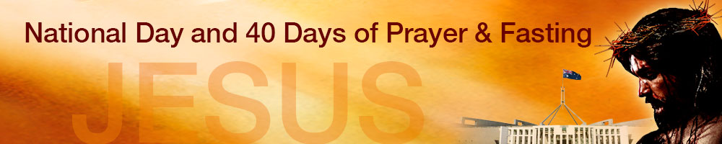
United Call to Prayer & Fasting
for Marriage and Families
through month of October 2016

On 15 September 2016, a gathering of Christian leaders from all over Australia confirmed their support for a call by the Catholic Church for a month of Prayer and Fasting for marriage and families throughout October 2016.

Approximately a dozen denominational leaders, church network leaders and prayer leaders called for all Christian churches and Christian organisations across the nation to get behind this important call for prayer. Key Christian Aboriginal leaders are also supporting this call for prayer and fasting to protect marriage from redefinition. Marriage between a man and a woman is sacred in Indigenous culture. Together all these leaders congratulated the Catholic Church for showing leadership and taking the initiative on this important issue.

See this website for more information regarding Indigenous perspective on sacredness of marriage: www.ulurubarkpetition.com

The team at the National Day of Prayer & Fasting, in cooperation with the Canberra Declaration, are going to provide a daily email devotion comprising a scripture, short inspiration and prayer for all those who want a digital daily inspiration.

Sign up for the daily devotional for October about celebrating and protecting God’s plan for marriage. Click here.

Warwick Marsh and James Condon, the co-convenors of the gathering, have asked other denominational leaders and Christian organisations to urgently register their support for this period of Prayer & Fasting for Marriage and Families during the month of October. Do this by midnight 22 September 2016 by emailing one of the email addresses listed below. Feel free to ring if you have any questions.

Email: James Condon james.condon@aue.salvationarmy.org
National Day of Prayer & Fasting www.nationaldayofprayer.com.au
Phone: 0478 301 468

Email: Warwick Marsh warwick@webshield.net.au
National Day of Prayer & Fasting www.nationaldayofprayer.com.au
Phone: 0418 225 212

