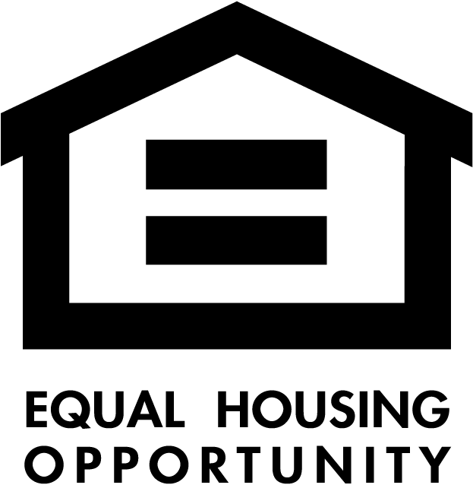
Consider using the equal housing disclaimer and/or logo. (This is not required by law but serves as evidence of your commitment). The disclaimer states that you will not discriminate on the basis of a federal or state protected class.

Protected Classes | Description | Also covered in federal law
Race | Generally, a member of a group united or classified together based on a common history, nationality or geography. | Yes
Color | The color of a person’s skin. | Yes
Family Status | A household with minor children. A person who is pregnant or seeking custody of a child, or is planning adoption or guardianship is included. | Yes
Disability | Having a physical or mental impairment that substantially limits one or more major life activities, or having a record of, or being perceived as having a disability. | Yes
Sex | Being male or female. | Yes
National Origin | Generally, a member of a nation by birth or naturalization or having common origins or traditions. | Yes
Religion | Sincerely held religious, moral or ethical beliefs and practices. | Yes
Marital Status | The status of being married, widowed, single, divorced, or separated.
Ancestry | The country, nation or tribe of the identifiable group from which a person descends.
Source of Income | The lawful source of a person’s income, including wages, a voucher having monetary value, social security, public assistance or other related payments.
Sexual Orientation | Having a preference for heterosexuality, homosexuality, or bisexuality or having a history of being so identified.
Age | Being at least 18 years of age.
Status as a Victom of Domestic Abuse, Sexual Abuse or Stalking

The equal housing opportunity logo is a picture of a small house with the words “equal housing opportunity” directly beneath it. Note that the small house picture cannot be used without the words “equal housing opportunity” beneath it, but the words can be used without the small house picture. Although using a disclaimer and/or logo will not eliminate discrimination liability, it is one of the factors used in determining intent to discriminate. Here is a link to the logo: https://www.nar.realtor/logos-and-trademark-rules/equal-housing-opportunity-logo

