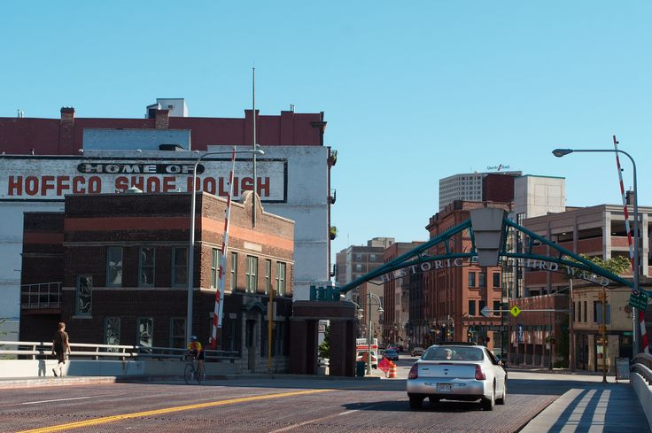
Downtown Diggs Condo Open House June 2nd 10am – 3pm
Please email the following condo listing information, and payment of $50,
to Stacie Lee Purko stacie@gmar.ws no later than Friday, May 25th.

Property Address:________________
_______________________________
Price:___________________________
Bedrooms: ______________________
Bathrooms: _____________________
MLS#:__________________________
Floors:__________________________
Number of Condo units:____________
Parking Garage:______#spaces______
Off Street parking:_____#spaces_____
Total Sq.Ft:______________________
Condo fee:______________________
Amenities:______________________
_______________________________
Broker/Agency:__________________
Phone Number:__________________

Any questions, call Stacie Lee Purko at 414-778-4929.
Thank you for your order! Make all checks payable to GMAR or pay by Visa/MasterCard.
Card Number_______-_______-_______-_______ Exp.________Signature____________________________
PLEASE RETURN A COPY OF THIS INVOICE WITH YOUR REMITTANCE

