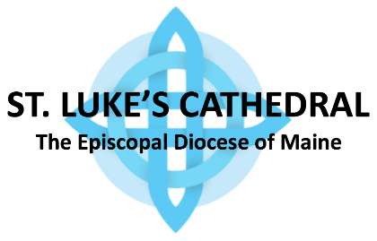
2022 PLEDGE CARD
“Test me, LORD, and try me, examine my heart and my mind.” Psalm 26:2

After prayerfully seeking God’s guidance and direction and in gratitude for the blessings God has given me/us, I/we pledge financial support, in the amount of $______________ per (circle one) week / month / quarter / year, to support God’s mission carried out in St. Luke’s Cathedral in 2022.
Name(s) _____________________________________________________________________
Address ___________________________ City, State, Zip ____________________________
Telephone(s) __________________________________________________________________
Email(s) ______________________________________________________________________
Date: _________________________________________
____ I/we will make a pledge online (www.stlukesportland.org -> Giving -> 2022 Pledge Card Online).
_____ I/we may use Vanco to make some or all of our pledge payments on-line
____ I would like 2022 pledge envelopes.
____ I/we give permission to the Cathedral to send contribution statements electronically to conserve resources.
____ I/we would like to be contacted about estate planning or planned giving.
I am interested in participating in the following missions, ministries and committees at St. Luke’s:
____________________________________________________________________________.
Please send me/us more information on St. Luke’s activities.
“Give and it will be given to you.´ Luke 6:38

