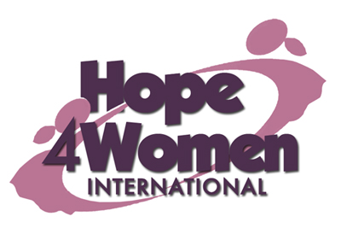
KINGDOM PREPARATION MINISTRIES
WOMEN SPONSORSHIP PROGRAM 2019

WOMAN’S PROFILE

Name : Nyachwo Christine

Age : 55 years

Marital status: married

Number of Children : 7(6&1b)

Number of grand children : 17

Village : Soni

Her story
Christine is 55 years old. She is the 4th born out of 4 children. She dropped out of school in primary six because she lacked school fees. In 1981 she got married to her husband Lawrence. He is a peasant. They produced seven children; Babra (39) married with 5 children, Rose (37) married with 5 children, Esther (35) married with 2 children, Auma (32) married with 3 children, Caro (27) not married but has 2 children, Teddy (21) not married and Lawrence (18) in P.7. class. Her current business is of selling fish with a capital of 30,000 shillings. The profit she gets is not enough to sustain the business and family as well. Her prayer is that when God opens the door and she gets support for a business, she will expand her business for more profits. This she believes will change her story. Christine has cervical cancer which has disturbed her for the last 16 years. She gets treatment from the nearby health center for some relief. Through the H4WI program she believes that she will be able to afford basic necessities for her family with ease, pay school fees for her children, expand her business and do a savings plan for other emergency needs of the family.

