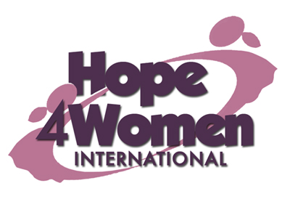

KINGDOM PREPARATION MINISTRIES
WOMEN SPONSORSHIP PROGRAM 2019

WOMAN’S PROFILE

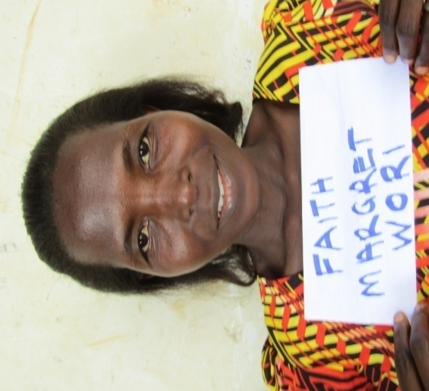

Name : Faith Margaret Awor

Age : 35 years

Marital status: married

Number of Children : 3

Number of grand children : none

Village : Juba

Her story
Faith is 35 years old. She is the 9th born out of 10 children. She graduated with a diploma in business administration. In 2016 she got married to her husband Posiano. He is a peasant. They haven’t produced any children yet. She adopted three children whose parents died when they were still young; Grace (17) in form 3 class, Elijah (14) in primary 7 class and Isaac (9) in primary 3 class. Her current business is of selling produce with a capital of 100,000 shillings. The profit she gets is not enough to cater for her family and sustain the business as well. She did not get formal employment after her course as most employers prefer able bodied people. Faith moves in a wheelchair. Her prayer is that when God opens the door and she gets support for a business, she will expand her business for more profit. This she believes will change her story. Faith has ulcers which have disturbed her for the last 3 years. Through the H4WI program she believes that she will be able to expand her business, afford basic necessities for her family with ease, educate her children and live a happy life.

