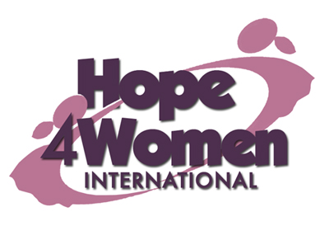

KINGDOM PREPARATION MINISTRIES
WOMEN SPONSORSHIP PROGRAM 2019

WOMAN’S PROFILE

Name : Veronica Abbo

Age : 43 years

Marital status: married

Number of Children : 6(1g&5b)

Number of grand children : 3

Village : Golumu

Her story
Veronica is 43 years old. She is the first born out of two children. She dropped out of school in primary four because her father died when she was still young. In 1991 she got married to her husband John. He is a peasant. They produced 6 children; Domini (24) married with 3 children, Lucy (22) not married but has 1 child, Gloria (18) in form 6 class, Abel (16) in form 1 class, John (14) in P.6.class and Samuel (12) in P.3.class Her husband went away 3 years ago in disguise looking for a job but up to now he has never appeared home. Veronica does not know where he is. Life is very hard for her financially. Her current business is of buying and selling of chicken with a capital of 50,000 shillings. The profit she gets is not enough to sustain the business and family as well. Her prayer is that when God opens the door and she gets support for a business, she will expand her business for more profit. This she believes will change her story. Veronica has a heart problem which has disturbed her for the last 3 years due to stress. She gets pain killers from the nearby health center for relief. Through the H4WI program she believes that she will be able to expand her business by selling cooked food and silver fish, afford basic necessities for her family, educate her children, do a savings plan for other family emergency needs and be able to afford medical treatment for herself.

