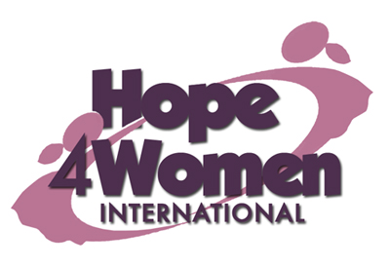
KINGDOM PREPARATION MINISTRIES
WOMEN SPONSORSHIP PROGRAM 2019

WOMAN’S PROFILE

Name : Bulandina Alowo

Age : 70 years

Marital status: widow

Number of Children : 7(3g&4b)

Number of grand children : 8

Village : Senda

Her story
Bulandina is 70 years old. She is the 7th born out of seven children. She never went to school because her parents had no school fees. In 1965 she got married to her late husband Lawrence. He was a peasant. They produced seven children: Florence (54) married but no children, Moses (50) not married, Ofamba (46) married with 6 children, Akello (44) married no children and Omita (42) married with 2 children. In 2013 the husband died of T.B. Since then life has been too hard for her financially. Her current business is of selling tomatoes with a capital of 30,000 shillings. The profit she gets is not enough to cater for her family basic needs. Her prayer is that when God opens the door and she gets support for a business she will expand her business for more profit. This she believes will change her story. Bulandina has a hernia and heart burn which has disturbed her for the last 3 years without treatment. Through the H4WI program she believes that she will be able to expand her business, afford medical treatment for herself, do a savings plan and afford basic necessities for her family.

