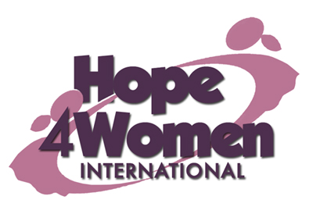

KINGDOM PREPARATION MINISTRIES
WOMEN SPONSORSHIP PROGRAM 2019

WOMAN’S PROFILE

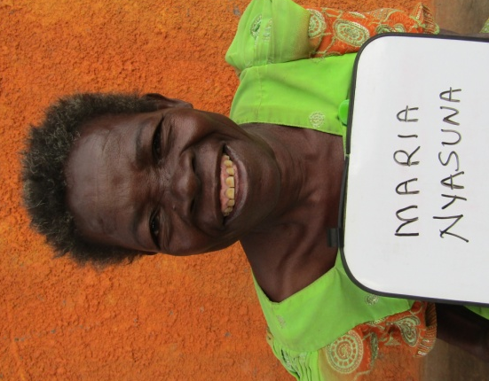
Name : Maria Nyasuna

Age : 70 years

Marital status: widow

Number of Children : 2(1g&1b)

Number of grand children : none

Village : Sesera

Her story
Maria is 70 years old. She is the 3rd born out of 3 children. She never went to school because her parents died when she was still young. In 1972 she got married to her late husband Odongo. He was a peasant. They produced two children but they both died. In 1984 the husband died of natural causes. Life became very hard for Maria. She lives a lonely life because her husband and children all died. She survives by begging for help or sometimes she goes to work in people’s garden irregularly. She has no current business because she lacks startup capital. Her prayer is that when God opens the door and she gets support for a business, she will start a business of buying animals like goats and pigs. This she believes will change her story. Maria has a cough which has disturbed her for the last 50 years. She was told that she has bone cancer. Through the H4WI program she believes that she will have a business, afford basic necessities for her family with ease, proper medical treatment for herself and live a life of hope.

