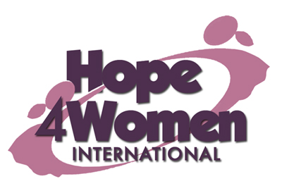

KINGDOM PREPARATION MINISTRIES
WOMEN SPONSORSHIP PROGRAM 2019

WOMAN’S PROFILE

Name : Mary Nyadoi
Age : 47 years

Marital status: widow

Number of Children : 6(5g&1b)

Number of grand children : 4

Village : Panangola

Her story
Mary is 47 years old. She is the 5th born out of 10 children. She dropped out of school in primary 7 because she lacked school fees. In 1991 she got married to her husband Peter. He was a peasant. They produced 6 children; Immaculate (27) has 1 child, Hellen (25) married with 1 child, Brenda (22) married with 2 children, Joana (20) in form 2 class, Emmanuel (15) in P.4.class and Athago. In 2010 the husband died of HIV/AIDs and left her with the children. Since then life has been hard for her and the children. She has no current business because she lacks startup capital. Her prayer is that when God opens the door and she gets support for a business, she will start a business in order to be able to support her family with ease. This she believes will change her story. Mary is HIV positive for the last 9 years and on ARVs. Through the H4WI program she believes that she will be able to educate her children, expand her business, afford basic necessities for her family and do a savings plan.

