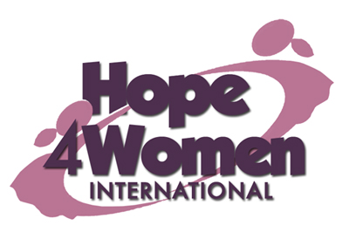

KINGDOM PREPARATION MINISTRIES
WOMEN SPONSORSHIP PROGRAM 2019

WOMAN’S PROFILE

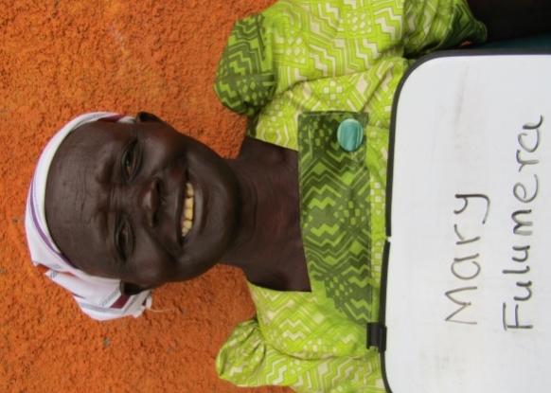
Name : Fulumera Awor

Age : 62 years

Marital status: married

Number of Children : 4(3g&1b)

Number of grand children : 16

Village : Pasukula

Her story
Fulumera is 62 years old. She is the 2nd born out of 2 children. She dropped out of school in primary four because she lacked school fees. In 1971 she got married to her husband Noah. He is a peasant. They produced 4 children; Gerald (30) married with 7 children, Florence (29) married with 4 children, Nezina (27) married with 2 children and Maria (25) married with 3 children. Fulumera has no current business because she lacks startup capital. Her prayer is that when God opens the door and she gets support for a business, she will start selling fish. This she believes will change her story. Fulumera has an eye problem which has disturbed her for the last 6 years without proper treatment. She gets pain killers from the nearby health center. Through the H4WI program she believes that she will be able to afford basic necessities for her family, afford proper medical treatment and do a savings plan for future investments.

