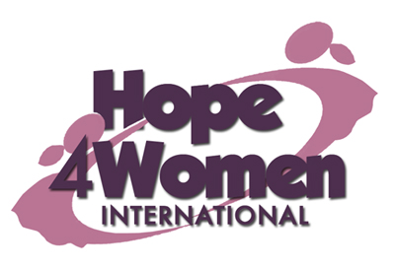

KINGDOM PREPARATION MINISTRIES
WOMEN SPONSORSHIP PROGRAM 2019

WOMAN’S PROFILE

Name : Adikin Mirabu

Age : 66 years

Marital status: widow

Number of Children : 7(5g&2b)

Number of grand children : 21

Village : Chalumba

Her story
Mirabu is 66 years old. She is the 9th born out of 13 children. She never went to school because she lacked school fees. In 1971 she got married to her first husband Ernest who was a peasant. They produced 2 children but one died. She separated with Ernest because he mistreated her a lot. In 1978 she got married to her second husband Yofisa. He was a carpenter. They produced 4 children: Peninah (43) married with 11 children, Jonson (38) married with 4 children, Tabnurse (34) married with 3 children and Yofisa (28) married with 3 children. In 2007 her husband died a natural death. Since then life has been hard for her financially. Her current business is of selling silver fish with a capital of 40,000 shillings. The profit she gets is not enough to cater for her overwhelming family needs and necessities. Her prayer is that when God opens the door and she gets support for a business, she will expand her business for more profits. This she believes will change her story. Mirabu has a hernia and ulcers which has disturbed her for the last 30 years. Ahe gets treatment from the nearby health center for some relief. Through the H4WI program she believes that she will be able to expand her business, support her grandchildren’s education, do a savings plan and afford basic necessities for her family.

