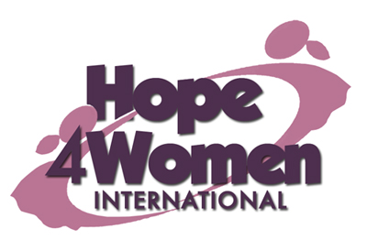

KINGDOM PREPARATION MINISTRIES
WOMEN SPONSORSHIP PROGRAM 2019

WOMAN’S PROFILE

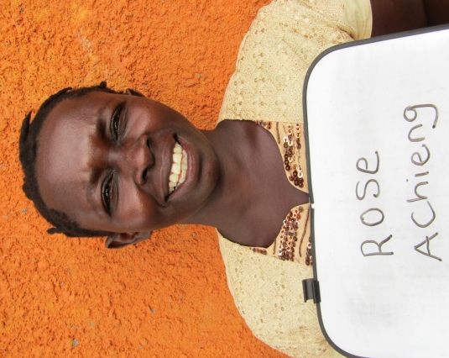
Name : Rose Achieng

Age : 38 years

Marital status: married

Number of Children : 6(1g&5b)

Number of grand children : none

Village : Chalumba
Her story
Rose is 38 years old. She is the 5th born out of seven children. She dropped out of school in primary three because she lacked school fees. In 1998 she got married to her husband Vicente. He is a builder. They produced 6 children; Benard (19) in form 2 class, Charles (17) in form 1 class, Alex (14) in P.5.class, John (12) in P.4.class, Lawrence (10) in P.2.class and Mary (5) in nursery top class. Her current business is of selling silver fish with a capital of 40,000 shillings. The profit she gets is not enough to cater for her family’s basic necessities. Her prayer is that when God opens the door and she gets support for a business, she will expand her business for more profit. This she believes will change her story. Rose has an eye problem which has disturbed her for the last 17 years. Her eyes pain her sometimes when there is a lot of light. She gets some treatment from the nearby health center for some relief but not a cure. Through the H4WI program she believes that she will be able to expand her business, do a savings plan, educate her children and afford basic necessities for her family with ease.

