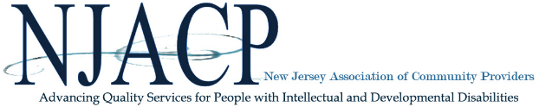

FOR IMMEDIATE RELEASE:
January 12, 2026
Contact: Maureen Shea
mshea@njacp.org / 609-406-1400, ext. 103
NJACP Supports Legislature’s Passage of A5634 (Murphy/Haider) / S3750 (Vitale/Bucco), Urges Policy Decisions Grounded in Facts and Collaboration
TRENTON, NJ — The New Jersey Association of Community Providers (NJACP), which represents nearly 80 agencies delivering community-based services to thousands of individuals with intellectual and developmental disabilities (I/DD) and their families across New Jersey, late yesterday expressed its support for the Legislature’s passage of A5634/S3750.
“Ensuring safe, high-quality services is at the core of the work our members do every day,” said Libby Vinson, CEO of NJACP. “We strongly support rigorous standards of care and accountability. Abuse and neglect are never acceptable and must be addressed swiftly and decisively, which are principles reinforced by this legislation.”
A5634/S3750 strengthens oversight within New Jersey’s community-based system and reflects what is possible when policymakers and stakeholders engage in good faith, grounded in facts and shared responsibility. NJACP applauds the bill’s sponsors, Assemblywoman Murphy and Senator Vitale, for their thoughtful leadership and willingness to listen, refine, and strengthen the legislation to ensure it is fair and workable for providers, families, and the individuals they serve.
At the same time, NJACP is concerned by narratives suggesting that abuse or neglect is widespread across New Jersey’s community-based system. Such portrayals are inaccurate and harmful, undermining dedicated professionals, eroding trust, and weakening a system that overwhelmingly delivers compassionate, person-centered, high-quality care. Collaboration, not division, is essential to achieving meaningful and lasting outcomes.
While this legislation represents an important step forward, NJACP urges policymakers to place greater emphasis on prevention in the next Legislative Session by strengthening hiring protections, ensuring system stability through adequate FY27 funding, and investing in workforce development to recruit and retain direct support professionals and human service leaders who are essential to quality care.
“NJACP remains committed to working with legislative leaders, state partners, providers, families, and individuals to strengthen New Jersey’s commitment to safety, accountability, and high-quality services,” Vinson said. “Lasting solutions are built on reason, evidence, and collaboration, not fear or rhetoric. The passage of A5634/S3750 shows what can be achieved when the I/DD community comes together around shared goals, and we look forward to continuing this work as a proactive partner.”

