A Federation Dream Come True!
As many of us in the Federation are aware, The U.S. Federation of Sisters of St. Joseph made a substantial 10-year commitment to the people of Haiti, from 2011 through 2021, to the children of Haiti, through a partnership with Mission Haiti, Inc., of Minneapolis. A wonderful collaborative venture called, The Empowerment of Girls Grant was the vehicle by which our Federation made a commitment to serve the educational needs of 10 Haitian girls from their first days of school in grade 1 at Annunciation school in Leogane, through their high school years at College Coeur de Marie, also in Leogane.

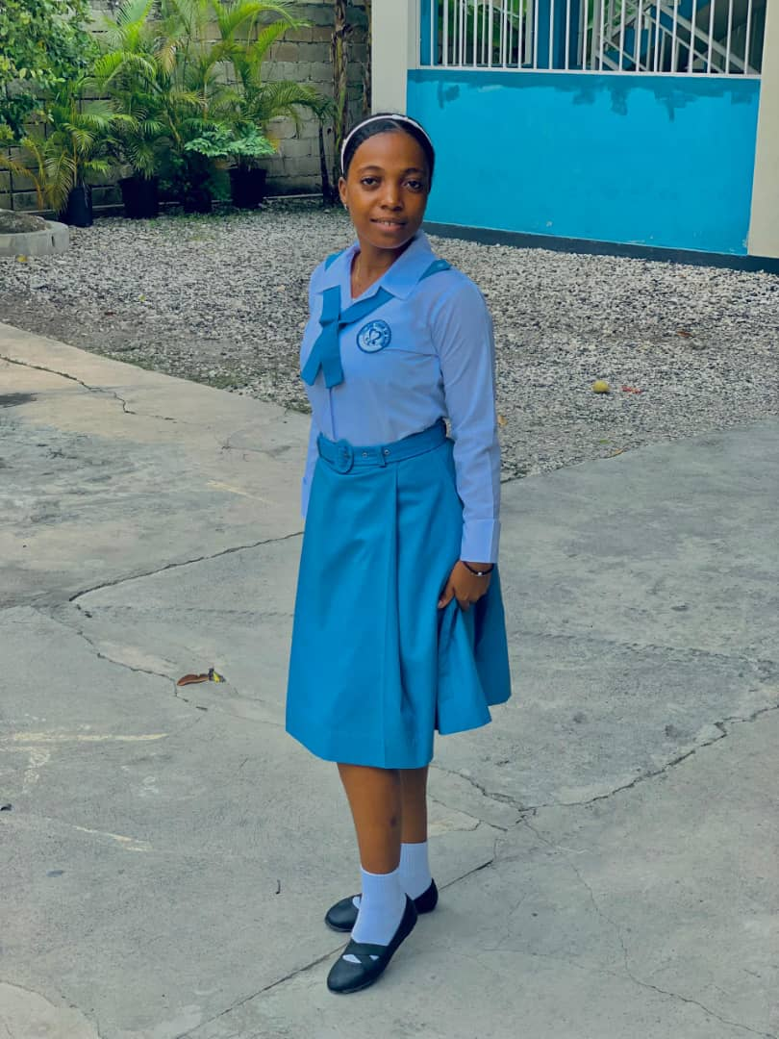
This joint venture between Mission Haiti, Inc. and our Federation was begun in 2011 as a response to the devastating death and destruction caused by the 2010 earthquake in Port-au-Prince and throughout Haiti. For the last eight years, this island nation has been rocked by a multi-year situation of gang violence which controls of the lives of the Haitian people. Yet though it all, the Companions of Jesus have been able to continue the education of Haitian children. During these years, our 10 girls have been able to complete their elementary and high school years of education at Annunciation elementary school, and College Coeur de Marie High School, With the disruption of civil life due to “gang rule,” the Sisters have lost contact with some of these students, but not of all of them. For those with whom contact has been restored, these young women feel free to return to Leogane. We would like to introduce you to Anastacia Michel!

Anastacia is one of those 10 girls who would not have had the opportunity for both an elementary and a high school education were it not for The Empowerment of Girls Grant. Anastacia is attending a four-year nursing program at a professional nursing college in Leogane. It’s wonderful that this program is available to her, since attending a nursing program in Port-Au-Prince, it would simply be too dangerous for her to travel there for her further education.

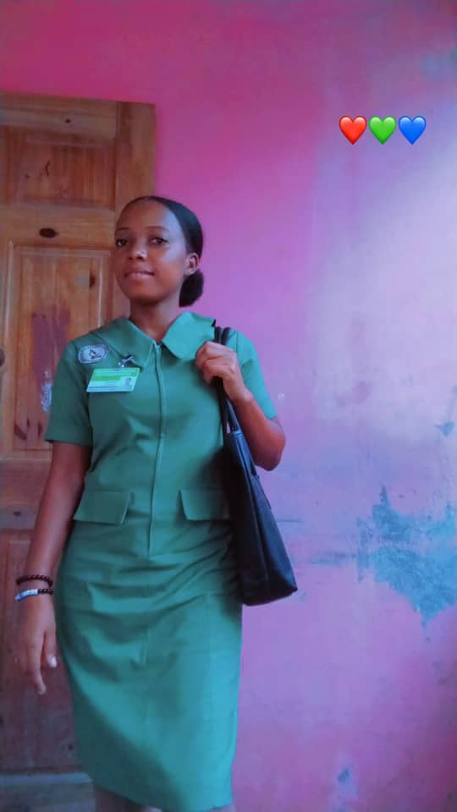
Anastasia is pictured here in her College Coeur de Marie uniform during her last year of high school. Here is a current picture of Anastasia in her uniform as a student in the nursing school program in Leogane, Haiti.

Though the 10-year Empowerment of Girls Grant came to a completion in 2021, approximately $7100.00 remains of the funds that were collected over the 10 years from 2011 to 2021. Mission Haiti has been holding these funds for the purpose of helping the Empowerment of Girls Grant program graduates with funding needs as they pursue higher education.

