For Cattlemen in San Luis Obispo County
Forage Losses 2021-2022 Growing Year
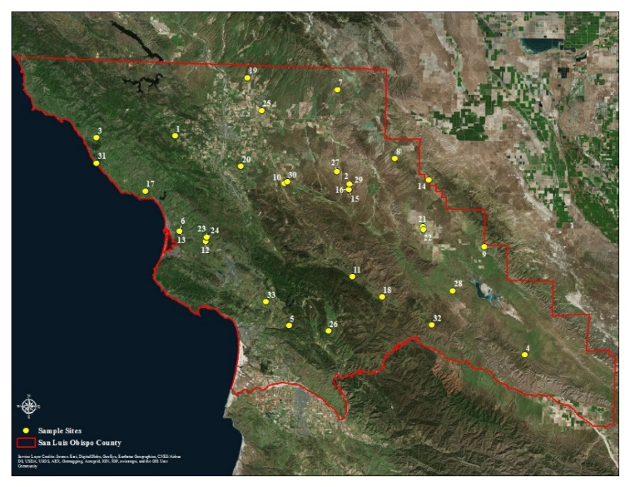
San Luis Obispo County rangeland has high variability in productivity across the county. We have 31 monitoring sites (Figure 1) distributed across the county that gives a good summary of forage production. However, not all areas are represented by the monitoring sites due to differences in environmental factors such as soil type, slope, aspect, plant species, temperature, and rainfall timing and amount, and elevation. Therefore, the analyses of forage losses should include input from ranchers. The main driver of forage growth is rainfall. The county was divided into 3 different rainfall zones (regions) by the Farm Service Agency, see figure 2. All losses are based on an average production for the site. Some years are above average, and other are below.

Figure 1. Location of the 31 forage monitoring sites in San Luis Obispo County. These sites were established between 2000 – 2015. (Figure prepared by Jessica Boone, Althouse and Meade, Inc.)

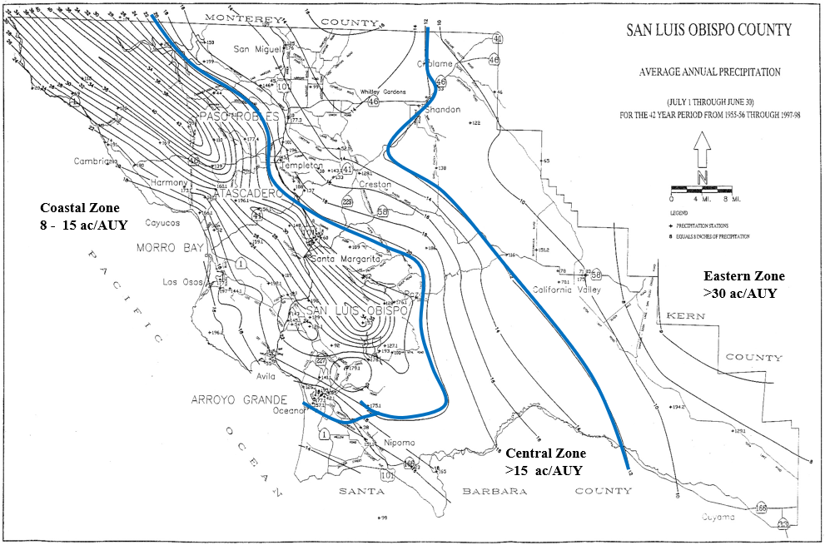
Figure 2. Stocking rates (grazing capacity) and related rainfall zones or regions, in San Luis Obispo County. This division is defined as: 1) coastal zone (greater than 20 inches; 8-15 acres per animal unit year (ac/AUY), 2) central zone (between 20 and 12 inches; 15-30 ac/AUY), and 3) eastern zone (less than12 inches; >30 ac/AUY). Definitions: ac = acre, AUY = Animal Unit Year (the amount of forage needed to support a 1,000 lb cow for one year.

The amount of forage that grows is strongly related to rainfall amount and timing and changes each year Figure 3. The forage losses are based on the average production for each zone (region). The average for the coastal zone is 3868, central zone is 2548, and the eastern zone is 1401 pounds per acre, respectively, Figure 4. Losses this year were: Coastal 48%, Central 77%, and Eastern 91%.

Figure 3. Forage production by zone (region) for 2001-2022.

All values are in lb/ac
Figure 4. Average forage production by zone based on our monitoring sites. This graph shows the expected production in pounds per acre, and what was measured this year from our monitoring sites. Averaged for each zone (region).

Even though the monitoring sites give a good overview of forage losses for 2021-2022 growing season, they do not cover every ranch and area in the County. Please provide information for your ranch by going to this link and completing a survey. You will also need to use a code. The code will ensure the accuracy of the data collected. Anonymity for respondents will be maintained.
Link for Survey: https://forms.office.com/g/Am2mib0jgZ Code is: 2022

