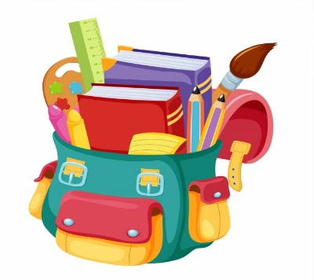
Arizona Reservation Ministries

Backpack Project 2020
Please return all donations to FCC
by June 28, 2020

With your help over 1000 students of the San Carlos Apache Reservation will receive much needed school supplies.
Following is a list of items with the marked items being especially needed.

- Brand-new backpacks (no owl prints please)
- Facial tissue boxes (Kleenex type)
- Individually wrapped toothbrushes & toothpaste
- Regular crayons & fat crayons for preschoolers
- Coloring books
- Pocket folders
- Colored pencils
- Regular #2 pencils & fat pencils for preschoolers
- Cap erasers
- Ink pens – BLUE, BLACK & RED
- Composition & spiral bound notebooks
- Glue sticks
- Pencil boxes and zippered pencil pouches
- 3-ring Binders (2” wide)
- Boxes of markers
- Highlighters & black dry erase markers
- Pkgs of binder dividers
- Index cards
- Wide-ruled loose-leaf notebook paper
- Small scissors
- Calculators
- Pkgs. of graph paper
- Pkgs. of Post-it notes

NOTE: Pencil sharpeners are NOT allowed in the schools.

ALL items need to be brand-new. You can also donate Wal-Mart or Dollar Tree gift cards. Deadline to have all items to First Christian Church is June 28, 2020.

