April 2024- Virtual & In Person Workshops (Subject to Change)
Military & Family Readiness Center (M&FRC) 3435 Broidy Road, JB MDL NJ 08641
To register for workshops, go to https://booknow.appointment-plus.com/3yjbr5kq/10 (Chrome) or contact 609-754-3154.
Virtual meeting information will be emailed to you after registration.
*Newcomers Orientation held at Timmermann Center / Pre & Post Deployment are in Bldg. # 3101*
Monday | Tuesday | Wednesday | Thursday | Friday | Saturday
1 | 2 Newcomers Orientation & Info Fair  (0800-1230) IP  Post-Deployment Briefing (0900-1000) IP  Corporate Fellowship Program Overview (1200-1300) V | 3 Leaving the Dorm (0900-1100) IP  Civilian Resume Writing Workshop (0900-1200) IP  Spouse Employment 101 (1800-2100) E/IP | 4 Pre-Deployment Briefing (0900-  1000) IP  Post-Deployment Briefing (1400-1500) IP | 5  First Duty Station-Officers (0900-1000) IP | 6
8  Personal Finance Questions & Answers  (0900-1200) IP/L  Veteran Readiness & Employment (1000-1100) IP/L | 9  Post-Deployment Briefing (0900-1000) IP  Commander’s Key Support Program (CKSP) Refresher Training (1000-1100) IP | 10 Federal Resume Writing  Workshop (0900-1200) IP  EFMP: What’s In It for Me? (1000-1100) IP  Evening Federal Resume Writing Workshop (1800-2100) IP/E  ***Held at Lakehurst*** IN-PERSON Transition (TAP) Curriculum Workshop | 11  Pre-Deployment Briefing (0900-  1000) IP  Unit Voting Assistance Officer (UVAO) Training (1000-1100) IP  Post-Deployment Briefing (1400-1500) IP  How to Vote 101 (1400-1500) IP | 12 | 13
15  Personal Readiness Seminar  (1300-1400) IP | 16  Post-Deployment Briefing (0900-1000) IP  Commander’s Key Support Program (CKSP) Initial Training (0830-1300) IP  Leaving the Dorm (1300-1400) IP | 17  Bundles for Babies (0900-1100) IP | 18  Pre-Deployment Briefing (0900- 1000) IP  Annual Volunteer Recognition Ceremony (1400-1600) @ Tommy B’s  Post-Deployment Briefing (1400-1500) IP | 19 TSP Vesting (0900-1000) IP  EFMP Outreach – Exchange (1100-1300) IP  Promotion (1300-1400) IP  PCS (1400-1500) IP  Hearts Apart: Bunnies & Pastels (1730-1930) E/IP | 20
22  Veteran Readiness & Employment (1000-1100) IP | 23  Post-Deployment Briefing (0900-1000) IP | 24  Plan My Move-Smooth Move  ***Held at McGuire*** IN-PERSON SENIOR Transition (TAP) Curriculum Workshop  (0900-1030) IP | 25 Pre-Deployment Briefing (0900-  1000) IP  Heart Link (0900-1330) IP  LinkedIn 101 (0900-1100) IP  EFMP Outreach-Lakehurst (0900-1500)  Post-Deployment Briefing (1400-1500)IP | 26 | 27
29  Sponsorship 101 (0900-1000) IP  TSP-Uniform Services (0900-1000) IP  TSP-Civil Service (1130-1230) IP | 30  Post-Deployment Briefing (0900-1000) IP  IN-PERSON Transition (TAP) Curriculum Workshops (VA, DOD & DOL) Monday thru Friday |  |  |  | Black: In-Person (IP)  Blue: Virtual (V)  Purple: Evening (E)  Orange: Lakehurst (L)
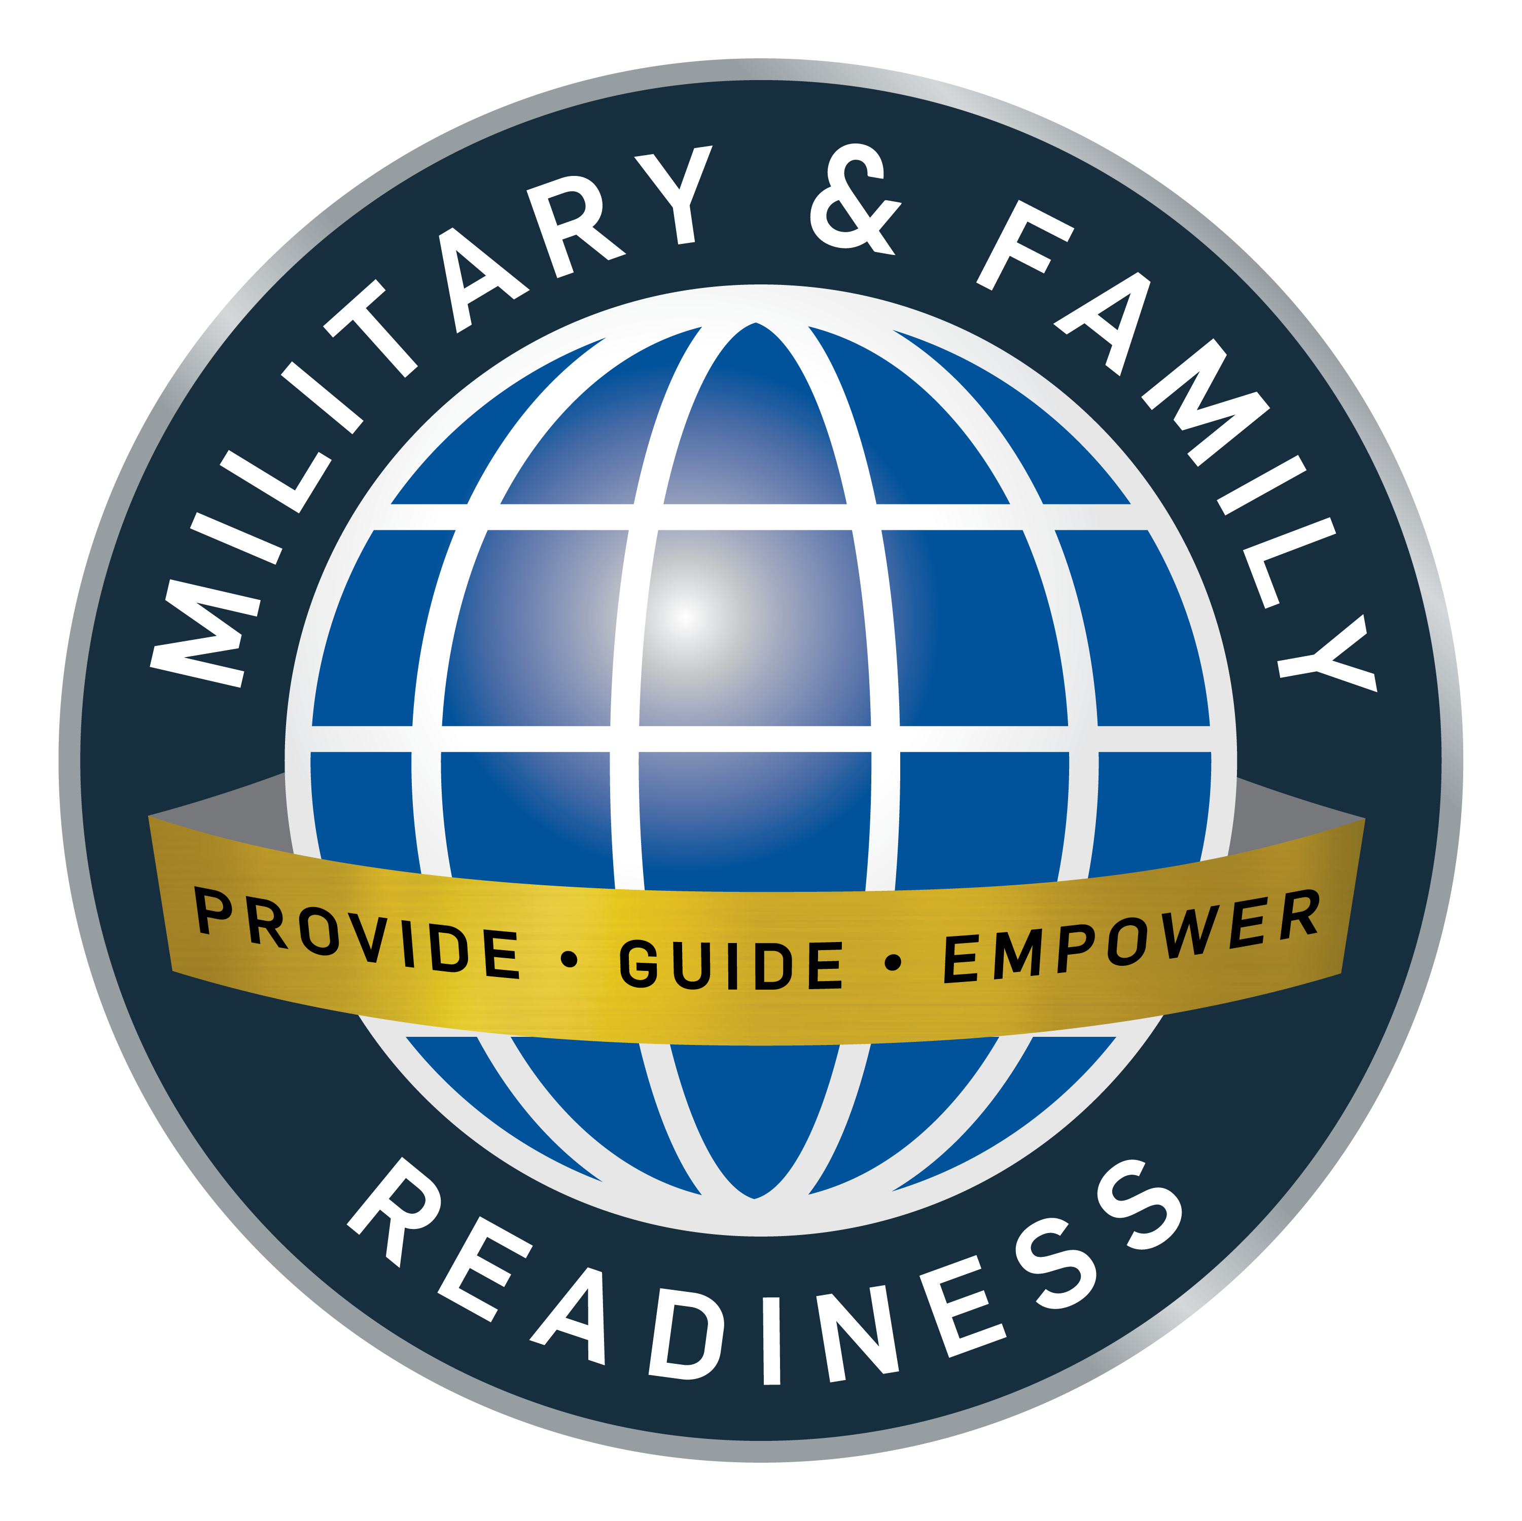

Are you interested in learning more about our workshops? For more information, or to sign up for workshops, please call our main line at 609-754-3154.

Bundles for Babies /Birth of First Child: How will you pay for your new bundle of joy? The M&FRC can help you get financially ready. The workshop covers budgeting for babies, Child/Youth Programs, FAP New Parent Support Program, and MFLC. All branches welcome! Qualified attendees will receive a "Baby Bundle Gift.” The workshop also meets the Birth of First Child mandatory financial touchpoint. Pre-registration is required.
Civilian Resume Writing Workshop: This class is a significant first step to making your civilian resume the best possible. The workshop instructs on topics such as resumes, cover letters, interviewing, and job search basics.
Corporate Fellowship Program: Overview for transitioning service members with management training and hands-on experience in the civilian workforce to prepare for a smooth transition to civilian careers. Pre-experience in the civilian workforce to prepare for a smooth transition to civilian careers. Pre-registration is required. For more information, call 609-754-3154.
Commander’s Key Support Program (CKSP) Initial Training: Initial CKSP training utilizes eight core modules in the standard Air Force Key Support training curriculum and fulfills the mandatory training requirement for newly appointed CKSP Liaisons. Newly appointed CKSP Liaisons must complete this training as well before taking Key Support Mentor training. An appointment letter signed by the Commander is a pre-requisite. Lunch will be provided. Pre-registration is required. Register online: https://booknow.appointment-plus.com/3yjbr5kq/. For more information, please call the Military & Family Readiness Center at 609.754.3154.
Commander’s Key Support Program (CKSP) Refresher Training: A refresher course is mandatory for CKSP Liaisons and CKSP Mentors upon relocation/PCS or as directed by the Commander. Please provide certificates of completion for initial KS or KSM training (if applicable) and an updated appointment letter. Pre-registration is required by calling the Military & Family Readiness Center at 609.754.3154.
EFMP Outreach-Exchange: Please stop by and see your EFMP Team! We can answer your questions or chat. We look forward to seeing you there! McGuire Exchange: 3452 Broidy Rd, JB MDL, NJ 08641
EFMP Outreach-Lakehurst: Please stop by and see your EFMP Team! We can answer your questions or chat. We look forward to seeing you there! Lakehurst Flight Deck Community Center: 484 Lansdowne Road, JBMDL Lakehurst.
EFMP What’s In It For Me? Do you ever wonder what each Exceptional Family Member Program (EFMP) component offers or who does what for you and your family? This workshop will help you learn the ins and outs of the EFMP's different roles of EFMP Family Support Coordinators, Special Needs Coordinators, Assignments, and community partners. Your opportunity to better understand and maximize your benefits and obtain local, state, and federal resources available.
Federal Resume Writing Workshop – 10 Steps to a Federal Job: A must if you are seeking a Federal Position. Topics include setting up your USAJOBS Account, navigating USAJOBS, and Application/Resume musts. Attendees will receive Kathryn Troutman's "10 Steps to a Federal Job" book to take home. Registration is required: http://booknow.appointment-plus.com/3yjbr5kq/
First Duty Station-Officers: This workshop is mandatory for Officers arriving at their First Duty Station. The course covers basic financial information such as reading the LES, TSP, investing and savings, credit, and more. Pre-registration is required.
Hearts Apart: Bunnies & Pastels: HOP in for a night of fun at the April Hearts Apart event with Bunnies and Pastels. This event is open to families of all branches with a member who is within 30 days of deployment; currently deployed, TDY 30+ days; remote tour or 6 mos. post deployment. Registration is required.
Heart Link: Are you a spouse new to the military or JB MDL? Are you a spouse interested in learning about the many base and local resources available? This workshop will give you the tools to understand the military lifestyle, customs, and traditions. You will also gain information on benefits for you and your family, including spouse employment, Tricare, and Emergency Financial Relief. Lunch is included! Pre-registration is required: http://booknow.appointment-plus.com/3yjbr5kq/. Please call the Military & Family Readiness Center at 609.754.3154.
How to Vote 101: Make your vote count by knowing how to vote absentee. Your JB MDL Installation Voting Assistance Office is offering training on how to vote locally and absentee. Leave with a better understanding of Absentee Voting, Registering to Vote, the National Mail Voter Registration Form and how to use fvap.gov. Open to everyone! Pre-registration is required.
Leaving the Dorm: Consolidated information on moving out of the dorm. Topics include budgeting, government housing info, United Communities, legal, and much more.
LinkedIn 101: Are you LinkedIn to Networking? Are you new to LinkedIn or looking to maximize your account for career advancement? If so, this class is the place to be! Learn strategies to utilize your LinkedIn account in your job search, including customizing your LinkedIn profile, finding LinkedIn groups to join, and more!
Newcomers Orientation & Info Fair: Base Newcomers Orientation is mandatory for most permanent-party active-duty, and DoD civilian government employees. Spouses are also highly encouraged to attend this complete overview of the installation, support agencies, and community services. Info fair is from 10:15am -10:45am. No pre-registration is required.
Personal Finance Questions & Answers: Do you have questions about your finances? The M&FRC Financial Counselors are here to answer your questions about budgets, credit, car buying, and TSP. The M&FRC can also complete your military financial touchpoints. Please come over and see us! If you cannot make this time, please call the M&FRC at 609-754-3154, and we can schedule you for a convenient time! Military & Family Readiness Center, 484 Lansdowne Rd Rm 108., JB MDL Lakehurst
Personal Readiness Seminar: This seminar provides an in-depth look into each of your critical readiness documents to include the Virtual Record of Emergency Data and Servicemembers’ Group Life Insurance, with real-world experience and insight from our Casualty Assistance Team. This seminar is open to service members, spouses, and dependents. Military & Family Readiness Center at 609.754.3154.
PCS: PCSing expenses, resources, and financial planning; mandatory class for E4/O3 and below will meet My Vector requirement.
Plan My Move- “Smooth Move”: Relocating is no easy task, but your M&FRC ensures you have a "Smooth Move" to your next destination! Reduce stress with this overview of vital relocation resources to help organize your "To-Do" list and execute a well-planned PCS. Spouses are encouraged to attend. Pre-registration required.
Promotion: Promoted and extra money; need tips on your newly found wealth? Mandatory classes for E-2 to E-5 and O-2 to O-4 will meet My Vector requirement.
Spouse Employment 101: The military may throw a monkey wrench in best-laid plans, but your career doesn't have to be one of them. This class will show you the different job routes you can take and teach the basics of resume writing, the job search, and what agencies are hiring on and near the joint base. Military & Family Readiness Center at 609.754.3154.
Sponsorship 101: Want to pay it forward and enhance the relocation process for newly assigned members and families? This workshop is for you! Attendees will receive access to JBMDL's Electronic Sponsorship Packet with instructions and support. This training is required for Unit Sponsorship Program Monitors and optional for Sponsors. However, both must complete eSAT training before performing sponsorship duties.
Transition "TAP" Curriculum: TAP Curriculum gives the foundation for service members and their families to be better prepared to transition from military to civilian life. The curriculum consists of Day 1: VA Benefits & Services. Day 2: Managing Your Transition, Military Occupation Crosswalk, Personal Financial Readiness and Unemployment. Day 3: Department of Labor Employment Workshop, and Survival Benefit Plan. MANDATORY Prerequisite: Individual Counseling (IC) and Pre-separation Briefing (eForm DD-2648). Spouses are encouraged to attend. Pre-registration is required.
TSP-Uniform/Civil: Overview of TSP; rules governing enrollment/participation, contributions, Investment funds, options, TSP components, and features. Pre-registration is required.
TSP Vesting: Questions on TSP or BRS? It is mandatory for Airmen who have reached two years of service and meet My Vector requirements. Pre-registration is required.
Unit Voting Assistance Officer (UVAO) Training: This training discusses the UVAOs FVAP.GOV certificates and portal login. Topics include instructions on the latest DAFI, metrics tracking, and mandatory touchpoints. Open to all branches. For more questions or to sign up, please call the Military & Family Readiness Center at 609.754.3154.
Veteran Readiness & Employment: Overview of VA services to help service members with job training, employment accommodations, resume development, and job-seeking skills coaching under the VR&E program. Spouses are encouraged to attend. Pre-registration is required.
Volunteer Recognition Ceremony: Tommy Bs Community Center, 2705 E. Arnold Ave., JB MDL. JB MDL Annual Volunteer Recognition ceremony for the base will include Wing leadership and the presentation of awards in multiple categories. Registration is required. RSVP: HTTPS://EINVITATIONS.AFIT.EDU/INV/INDEX.CFM?I=847745&K=0A65450E7F52

