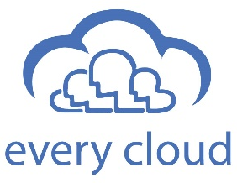

Anthony Delaney
+44 (0) 20 3372 5400
anthony@every-cloud.com
Job Title | Senior NAV Developer
Experience | 15+ years NAV Development experience – all versions to NAV2018  Customisation of modules: Sales, Purchasing, Finance, Logistics, Warehouse  C# ASP.NET, MS SQL Development experience  Upgrade Nav 2009 to Nav 2017  NAV Integration experience  API development and integration  MS Dynamics CRM
Location | NRW
Notice | 8 weeks
Salary | €75K

