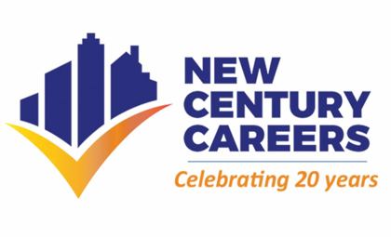
Bring your Business Message Directly to Prospects’ Inboxes
As we continue to celebrate our 20th anniversary year, New Century Careers is offering a unique opportunity to you, our faithful company partners and organizations, to promote your businesses while at the same time supporting our nationally recognized training programs that are creating skilled workers for in-demand manufacturing jobs in our region.
New Century Careers is now offering advertising packages that will enable you
to place banner ads within the NCC monthly newsletter.

The NCC newsletter is distributed via email to more than 1,000 local businesses, public officials and organizations that have a keen interest in manufacturing services, products and economic development. This is an easy and economical way to support New Century Careers while promoting your business.
Several affordable options are available, including discounted rates for a full quarter (3 ads):
$250/month or $650/quarter
Company logo, up to thirty-five words of text, link to your website

$150/month or $450/quarter
Company name and link to website

We’ll make it easy by composing your ad for your approval or submit an electronic file of your copy.
Reserve your space by 10/21 and your first ad can appear in the October issue.
Contact Rebecca Durkot, NCC Communications & Marketing Specialist, at 412.212.0005 or durkot@ncsquared.com, for additional information.
Thank you for your ongoing support!
The NCC Marketing and Outreach Committee

