March 11, 2019

Dear Brothers and Sisters in Christ,

It is with great excitement and joy that I share the very good news that a new full-time clergy person will join our staff at St. John’s. On June 15, 2019, the Reverend Margie Baker will begin her work as our new curate. For those new to the Episcopal Church tradition, a “curate” is a recent seminary graduate and newly ordained clergy person. The curacy is their first placement in parish ministry, where they learn the ins and outs of serving a faith community.

Along with the responsibilities of preaching, celebrating and pastoral care, Margie’s primary focus will be leading the development of our new Christian education program for children and youth. As a former high school teacher, Margie brings a wealth of experience in education, as well as a passion for liturgy and music. Please read the letter from Margie that’s printed on the back of this one, to learn more about her and her family.

We are a growing faith community, and the parish leadership is committed to building an outstanding Christian formation program to take advantage of and continue that growth. Welcoming, educating and meeting the needs of children, youth and their families is vital, not just today, but also for future generations who will someday walk through St. John’s red doors. Having a qualified, energetic and faithful priest leading these efforts is an exciting step forward in ensuring St. John’s health and vibrancy for years to come.

Please join me in welcoming Margie and her family to St. John’s, and praying for them and for the church during this transition. More information will follow about specific ways you can help welcome them to West Hartford and our parish family.

In deep gratitude,

Susan+

Dear St. John’s,
I am so excited to begin my ordained ministry with you! I am currently a senior at Virginia Theological Seminary in Alexandria, VA, and I will graduate on May 16. I will be ordained a deacon on Saturday, June 8, in North Carolina. In the Episcopal Church, people called to the priesthood are ordained first to the diaconate, as a reminder that we are always called to serve.
At VTS, I am involved in crafting and leading a wide range of liturgies, from Evensong to Prayer and Praise, a contemporary Evening Prayer service. During my two-year internship at St. Columba’s Episcopal Church in Washington, DC, I experienced and contributed to their vibrant, preschool-to-high school formation program. I am passionate about how good formation at all ages creates a welcoming, lively parish ready to feel God’s love and be Christ’s hands and feet in the world.
Before answering the call to ordained ministry, I taught French and music in North Carolina for more than a dozen years. Most of that time was at a public magnet school on the campus of Guilford College, my alma mater. During my tenure I was a national board-certified teacher, earned a master’s in French literature, and served as school leadership chair. I love teaching and feel strongly that learning should never stop. I look forward to sharing the gospel with children, youth, and adults, as we learn together.
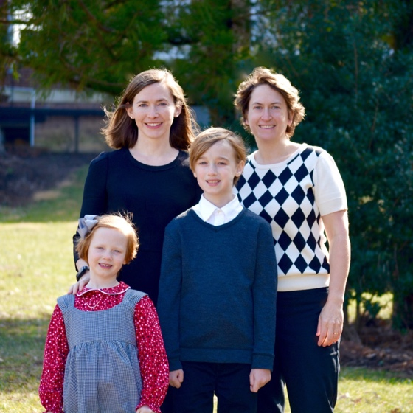
My family is excited to make West Hartford our home. My wife Jenn has a background in both Montessori education and environmental education. She makes some amazing sourdough and loves hiking, biking, and photography. James is in fourth grade and loves reading, Legos, reading, Minecraft, and reading. Eden is in second grade and loves gymnastics, playing outside, and making art. They both look forward to making new friends and playing in the snow. When I’m not studying or making music, I enjoy reading and running. I ran the Boston Marathon in 2017 and hope to make it back there one day.
I look forward to meeting you this summer! My first Sunday will be June 16. Please pray for my family and me as we make this transition.
Margie (left) with wife Jenn and children Eden and James
Peace,
Margie

