Library “JUNCTION 101” to Open MARCH 2017

JUNCTION 101 is the planned new ‘Make & Do Creative Zone’ for ages 8-12 slated to open in March of 2017 at the Jessie F. Hallett Memorial Library. After attending the Duluth Minnesota Library Association conference in late September, the Hallett library staff returned invigorated to begin implementing several of the key components. As explained by library trend watchers, “Libraries are no longer simply a holding area for books, they are community hubs. People gather at the library to share ideas and enrich their lives. Computers and internet are now commonplace in libraries and are often in demand. Unemployed individuals can apply for jobs, kids can do homework or play games at the library, but now libraries are much more than books, computers and internet. Libraries are becoming creation stations where students can create, build and craft.”
In 2015, IU2U (It’s Up to YOU!) was created as a vehicle to promote a teen program emphasizing mentorship, literacy and community beautification. Taking the JFHML teen mentorship a step further is the creation of JUNCTION 101 as a safe environment to develop relationships and a sense of community interchange
The new area will include workstations, supplies and opportunities for in-betweens, (ages 8-12) with Legos, Spirograph, origami, Magna, Anime, coloring & crafts. Design concept classes will be facilitated by community members each Tuesday evening in March between 6-7:30 pm.
FREE classes include: March 7 FANCY LETTERING with Kim Gibson
March 14 ELECTRONIC SWITCH CHALLENGE with Mike Beseres
March 21 CREATE with Sharon Simons
March 28 WEAVING with Amy Sharpe
Pre-registration is suggested (for supply purposes) but not required. Call 218-546-8005 to reserve a creative spot for any of the above Junction 101 Make & Do Tuesdays.
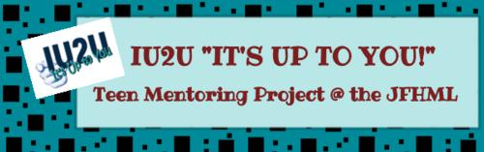
This project is made possible by funding from IU2U, the JFHML Friends Foundation and other donations.

