Your Development Team

Nancy Gwinnell Hurd, PMA®-CPT, BFA, M.ED.
Founder, Program Coordinator, Curriculum Development, Course Instructor
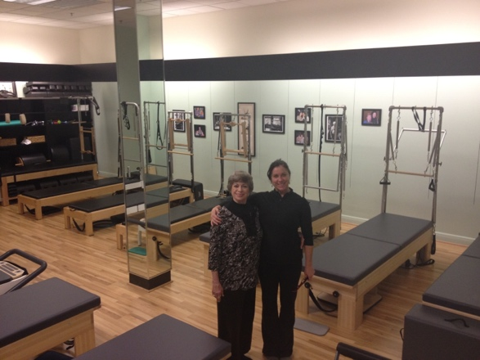

An educator for over 30 years, Nancy holds a BFA in Dance and a Masters in Education from Arizona State University. Nancy is a Second-Generation Pilates Teacher and is certified through Peak Pilates®, The Pilates Method Alliance, and The PilateSystem®. She is proud to be one of Lolita San Miguel’s disciples earning her the title of a Lolita San Miguel Master Teacher™ and to have originally trained with PMA co-founder Colleen Glenn. Additionally, Nancy was certified in Gyrokinesis™, The Gyrotonic Expansion System®, and Pilates for Golf. She is listed in Who’s Who among America’s Teachers and is a member of The Pilates Method Alliance and The Authentic Pilates Union.

Nancy has been a Peak Pilates® Master Trainer for over 17 years, was a member of the Peak Pilates® Leadership Team and is PMA CEC provider. She is the Director and Owner of Austin Pilates Barn and teaches workshops and trainings in Austin, throughout the US and has had the pleasure of sharing her work with trainers from around the world.

Her Passion is bringing the joy and health benefits of movement to a wide variety of people. Nancy has worked with populations ranging from athletes to re-hab, youth to elders, and novice to advance. She strongly believes in the success of every “body”.

Kristy Demers, PT, DPT
Curriculum Development, Course Instructor

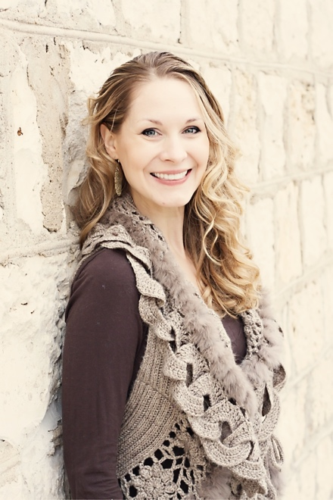

Kristy is a licensed physical therapist and a certified Pilate’s instructor. Kristy received her Doctorate of Physical Therapy from Washington University in St. Louis in 2006, and prior to that she graduated with her B.S. in Motor Development and minor in Psychology from Texas A&M University in 2002. Kristy has primarily practiced in the orthopedic sector of physical therapy since graduation where she primarily specializes in treatment of musculoskeletal pain syndromes of the spine, pelvis and extremities. Areas of expertise include movement impairment disorders, chronic pain, repetitive stress injuries, sports injuries, pregnancy and postpartum, osteoporosis, osteoarthritis, and scoliosis. Kristy enjoys combining her physical therapy and Pilate’s knowledge to identify impairments in movement, alignment, muscle length, strength, and stiffness and their relationship to the underlying cause of one’s pain.

Laura Phillips Hampton
PMA®-CPT, BFA, Peak Pilates® Master Instructor
Course Lead Instructor-Houston

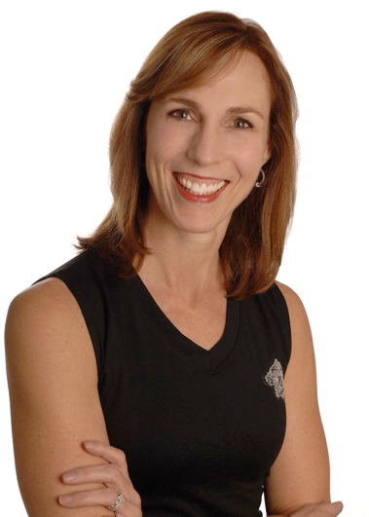

Laura has been a student of movement for most of her life. A Pilates teacher for over 15 years, and a was Master Instructor and Continuing Education provider for Peak Pilates. She believes that Pilates offers a way of moving that benefits everyone, regardless of age or fitness level. Her ongoing study focuses on healing movement, and restoring fitness, function, and balance to the body. Laura seeks out opportunities to learn and develop a deeper understanding of the body, and then opportunities to share this with other teachers and students. The founding president of the Houston Pilates Association, Laura works to support the profession of Pilates instructors, building community and bridges between teachers and studios.

Cherry Herzog
PMA®-CPT, Peak Pilates® Master Instructor, C.I.A.R
Course Lead Instructor-Dallas

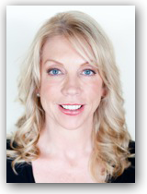

Cherry Herzog is a Texas native with over 30 years in the health and fitness industry. She completed her first certification with Physical Mind Institute in 1997 and in 1999 her formal Pilates training with Colleen Glenn at Goodbody’s Wellness Center in Dallas, Texas. She joined Peak Pilates in 2003 as a classical teacher trainer and presenter conducting certification courses and workshops locally and nationally. She is co-owner of Pilates Connection Studio/Peak Pilates training center in Dallas, Texas and is known and respected for her passion and dedication to excellence developing teachers from California to Florida and many states in between.

