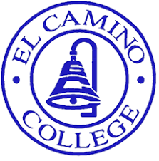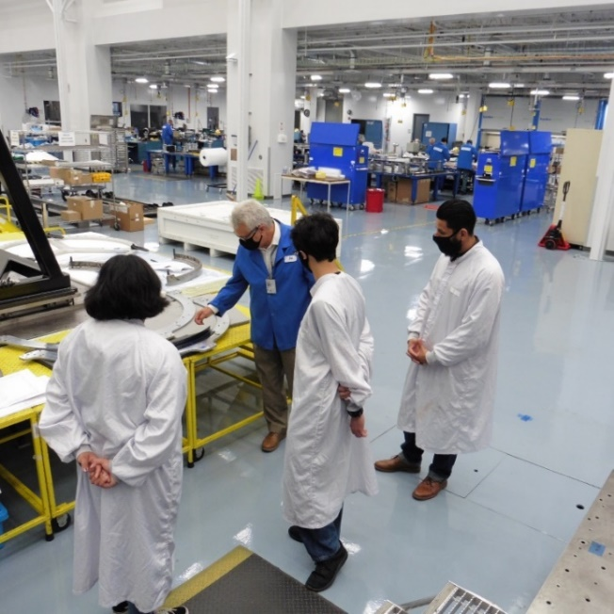

**The Winter Institute Will Consist Of**

* **5 weeks of winter instruction** 
  + **Monday to Thursday 8am-1pm**
  + **January 5th-February 5th, 2026**
* **Hands on training and work-based learning**
  + **At Northrop Grumman Space Park**
  + **Up to 100 hours of training**
* **Registration into ECC Co-operative ed course**
  + **1 unit of credit for participation with the employer**
* **Placement in areas of Aerospace Composites**
  + **Mentorship in areas of Aerospace Composites fabrication, repair, and inspection.**

**Advance Your Skills This Winter – 1-Unit Course, Big Impact!**

**Level up your skills this winter with our NEW immersive winter course focused on Aerospace Composites. Open to all El Camino College students studying Automotive Collision Repair and Paint, Electronics and Computer Hardware, Machine Tool Technology, and Engineering Technology.**

**Employer Eligibility Requirements**

* **Must be a current/past El Camino College student**
* **18 years of age or older**
* **In good academic standing with a minimum 2.0 Grade Point Average**
* **U.S. citizenship documentation is required for clearance by the employer (if selected)**
* **Complete and submit:**
  + **Interest Form**
  + **Email** [**spineda@elcamino.edu**](mailto:spineda@elcamino.edu) **to schedule an info meeting**
  + **Provide resume to** [**spineda@elcamino.edu**](mailto:spineda@elcamino.edu) **by deadline**
* **Attend an interview (if selected)**
* **Register for a winter co-op education course at El Camino College**

**\*More detailed information on process/US employment clearance can be found on the Interest Form**

**APPLICATIONS DUE: November 15, 2025**

**Link to Apply:** [**https://forms.gle/SAWukPkhQGLtfvqa8**](https://forms.gle/SAWukPkhQGLtfvqa8)