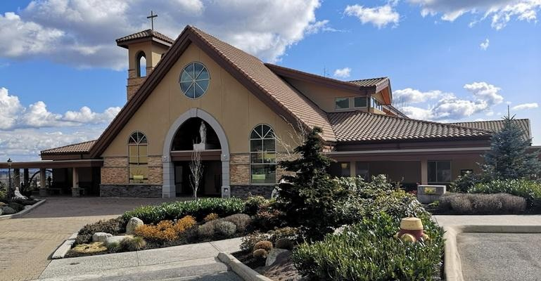
St. Clare of Assisi Catholic Parish
Rite of Christian Initiation of Adults
R.C.I A

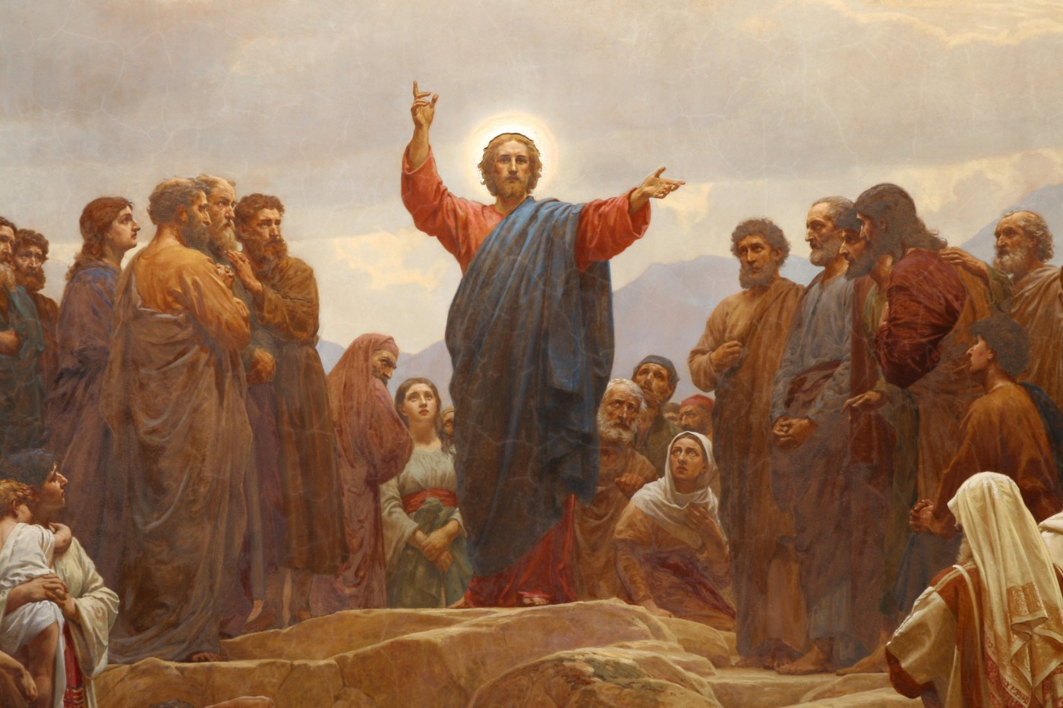

“In the first place, it is intended to stress that at
the heart of catechesis we find, in essence, a
Person, the Person of Jesus of Nazareth.”
- St. John Paul II, Catechesi Tradendae 5

Do you ever ask yourself…
What am I looking for in life?
What is the meaning of my life?
How can I be a better person?
What can I do about the loneliness I feel? How can I come to know God’s love?
How can I know the right path God has in store for me?
If you are asking these questions, or questions like them, the Catholic way of life awaits you. For centuries, people have turned to the Catholic Church to find the answers to the deepest and hardest questions of everyday life.
Why the Catholic Faith?
What do Catholics believe?
We believe in Jesus Christ.
Jesus Christ is the Son of God, sent to mankind by the Father, so that we may all have everlasting life. We believe that Jesus walked here on earth, just like you and me. He was conceived by the Holy Spirit and was born of the Virgin Mary in a humble manger in Bethlehem. We believe in the Incarnation - that God was made man without ceasing to be God. Thus, He is true God and true man. This man is Jesus Christ. Through Him we are called to be heirs of the Kingdom of Heaven. Jesus is the second person of the Holy Trinity: God the Father, God the Son, and God the Holy Spirit.
What is the Good News Catholics often talk about?
God created the heavens and the earth, and all who live in it. As His sons and daughters, we were created to be in relationship with Him forever in paradise. However, through the fault of our first parents, Adam and Eve, sin entered and broke our relationship with God. This created a great divide between us, a barrier that we can never fix on our own. Because of this, God sent His only begotten Son, Jesus Christ, to reconcile us to Him. Jesus was condemned to suffer for our sake -- leading to His death on the cross. His death bore our sin and shame and through this one act of love He fixed the broken relationship between us and the Father. We believe that Jesus died and went to the grave, and that in three days He rose again in glory. Through His death and resurrection, He conquered sin. His victory over death is our hope and our salvation. However, it does not end there. The Good News is about hope and the invitation that follows it. It is an invitation to get to know the person of Jesus Christ, in whom we place our trust.
It is an invitation to say yes to Him and to
encounter the Church.
We belong to a very big family.
During His time on earth, Jesus moved the hearts of many followers. He especially transformed 12 Apostles that He called by name and gave them authority to take care of the Church that He started on Earth. Jesus promised His believers that when He returns to Heaven, He will send for us an advocate. On Pentecost, the Holy Spirit came down to the early Church giving courage to the apostles to become fearless and courageous witnesses to Christ. On this day, the Church was born. The Holy Spirit broke down ethnic and linguistic barriers and united the Church, making us into a universal family. We are called the Catholic Church because, in Greek, the term katholikos means “universal”.
Over 2,000 years later, the Catholic Church is now a family of 1.3 billion people around the world. We are made up of people from all walks of life, called to different vocations, but with a simple mission: to love God and to love others.
Okay, I like what I just read and it speaks to my heart and mind.… now what?
What if I think that I want to become Catholic?
We believe that God calls individuals to live the Good News Jesus proclaimed and to become his disciples as members of the Catholic Church. If you want to become Catholic, you will participate in a process called the Rite of Christian Initiation of Adults (sometimes called RCIA or simply Christian initiation). In RCIA, you will learn about the teachings of Jesus as the Catholic Church has handed them on and put these teachings into practice by living as part of the Catholic
community, serving others and praying.

What does initiation into the Catholic Church involve?
If you have not been baptized, the Christian initiation process prepares you to become a Catholic Christian by celebrating what we call the sacraments of Christian initiation: Baptism, Confirmation and Eucharist.
If you have been baptized in another Christian tradition, the initiation process prepares you to enter into full communion with the Catholic Church by celebrating the sacraments of Confirmation and Eucharist.

I’m a baptized Catholic. Is RCIA for me?
If you have been baptized as an infant, but have not received further formal instruction in the Catholic Faith nor the sacraments of Confirmation or the Eucharist, RCIA is indeed for you.
If you are a fully initiated Catholic who wishes to deepen your faith, speak to your parish office or about the possibility of participating.

How long does it take to become a Catholic?
Becoming Catholic is a life-long commitment. However, the Christian initiation process typically lasts for several months or longer in order to prepare to take this step.
Participants in the initiation process generally meet once or twice each week, including part of the Mass on Sunday, but each parish initiation schedule varies.
The initiation of individuals who are ready to make the commitment to become new members of the Catholic Church may take place at Easter (in March or April) or at other times throughout the year.

What if I change my mind?
You do not make any commitment or obligation by inquiring about Catholicism or beginning the Christian initiation process. We want you to take the time you need as you think about becoming Catholic and we respect your decision to stop or to say, “not right now” at any time.
While we love being Catholic and hope that others will want to become Catholic also, we do not exert pressure on anyone to do so. Our hope would be that at the very least, you would come to a greater appreciation of Catholic beliefs and practices.

Websites to help you…
https://rcav.org/
https://stclare.ca/
https://beholdvancouver.org/
https://www.wordonfire.org/
https://ascensionpress.com/
https://www.goodcatholic.com/

Are you interested in finding out more about how to become a Catholic at St. Clare’s?
R.C.I.A. Sessions will be held on Thursday evenings at 7:00pm downstairs in our St. Clare’s Parish Centre.

For more information, please call our
Parish Office at 604-941-4800 or contact Marimae Matthews at 604-492-2001.

Classes begin: Thurs Sept 10, 2026
Last class before Christmas: Thurs Dec 17, 2026
Classes resume: Thurs Jan 7, 2027
Last Class: Thurs Apr 29, 2027

“I am the way, the truth, and the life. No one comes to the father except through me.” (John 14:6)
Here, Jesus is promising His disciples that not only will He be the road to salvation and eternal life in the Kingdom of Heaven, but that the road to salvation will take the particular shape of the Sacraments of the Church.

