
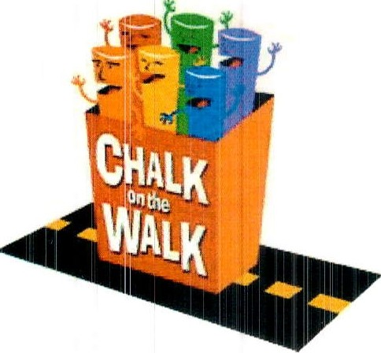

CHALK ON THE WALK

Presented by the Rotary Club of Cambridge

ARTIST PARTICIPATION FORM

Yes, I want to help The Rotary Club of Cambridge to continue “to do good in the community!”
Please sign me up to make a chalk painting at Cambridge Rotary’s "Chalk on the Walk"
in Harvard Square during Oktoberfest, Sunday, October 6, 2024

PARTICIPATION IS FREE!
Name (required)
E-mail (required) Phone

Please select the size painting you wish to do:
___ 5' x 7'
___ 6' x 8'
___ 7' x 9'
__ 8' x 10'
No preference

Please note that we will do our best to match you with a square of your selected choice, but we may need to assign you to an alternate size based upon sponsor sign ups.

Cambridge Rotary will find a square sponsor for you, but if you wish to find your own sponsor, please let us know.

Please initial all lines below (required):
__ I acknowledge that I have reviewed and will comply with the guidelines as outlined in the FAQs found on the Rotary Club of Cambridge website:
http://CambridgeRotary.org/ChalkFAQ.cfm
___ I further agree that my artwork must be appropriate for public viewing. No words or symbols intended as advertising may appear within the image. We supply washable sidewalk-type chalk and pastels; however, it is permitted for you to bring your own as long as they are okay for sidewalk use (no acrylics, no liquids).
__ I acknowledge that Chalk on the Walk is entitled to photograph and reproduce the street painting created by me (and my helpers) in any manner.

THANK YOU!
We will e-mail you useful tips and registration information prior to the event
For more information, call Joe Kobialka at 617-974-5336 or e-mail us at chalk@cambridgerotary.org

