Phases of Disaster
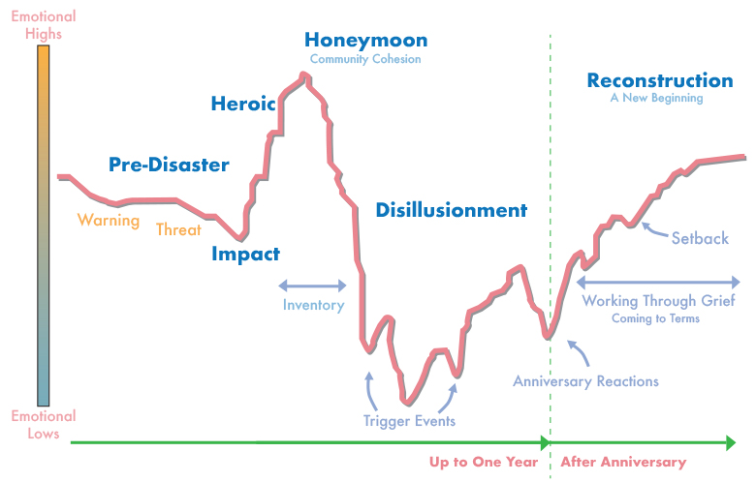
Adapted from Zunin & Myers as cited in DeWolfe, D. J., 2000. Training manual for mental health and human service workers in major disasters (2nd ed., HHS Publication No. ADM 90-538). Rockville, MD: U.S. Department of Health and Human Services, Substance Abuse and Mental Health Services Administration, Center for Mental Health Services.
- Phase 1, the pre-disaster phase, is characterized by fear and uncertainty. The specific reactions a community experiences depend on the type of disaster. Disasters with no warning can cause feelings of vulnerability and lack of security; fears of future, unpredicted tragedies; and a sense of loss of control or the loss of the ability to protect yourself and your family. On the other hand, disasters with warning can cause guilt or self-blame for failure to heed the warnings. The pre-disaster phase may be as short as hours, or even minutes, such as during a terrorist attack, or it may be as long as several months, such as during a hurricane season.
- Phase 2, the impact phase, is characterized by a range of intense emotional reactions. As with the pre-disaster phase, the specific reactions also depend on the type of disaster that is occurring. Slow, low-threat disasters have psychological effects that are different from those of rapid, dangerous disasters. As a result, these reactions can range from shock to overt panic. Initial confusion and disbelief typically are followed by a focus on self-preservation and family protection. The impact phase is usually the shortest of the six phases of disaster.
- Phase 3, the heroic phase, is characterized by a high level of activity with a low level of productivity. During this phase, there is a sense of altruism, and many community members exhibit adrenaline-induced rescue behavior. As a result, risk assessment may be impaired. The heroic phase often passes quickly into phase 4.
- Phase 4, the honeymoon phase, is characterized by a dramatic shift in emotion. During the honeymoon phase, disaster assistance is readily available. Community bonding occurs. Optimism exists that everything will return to normal quickly. As a result, numerous opportunities are available for providers and organizations to establish and build rapport with affected people and groups, and for them to build relationships with stakeholders. The honeymoon phase typically lasts only a few weeks.
- Phase 5, the disillusionment phase, is a stark contrast to the honeymoon phase. During the disillusionment phase, communities and individuals realize the limits of disaster assistance. As optimism turns to discouragement and stress continues to take a toll, negative reactions, such as physical exhaustion or substance use, may begin to surface. The increasing gap between need and assistance leads to feelings of abandonment. Especially as the larger community returns to business as usual, there may be an increased demand for services, as individuals and communities become ready to accept support. The disillusionment phase can last months and even years. It is often extended by one or more trigger events, usually including the anniversary of the disaster.
- Phase 6, the reconstruction phase, is characterized by an overall feeling of recovery. Individuals and communities begin to assume responsibility for rebuilding their lives, and people adjust to a new “normal” while continuing to grieve losses. The reconstruction phase often begins around the anniversary of the disaster and may continue for some time beyond that. Following catastrophic events, the reconstruction phase may last for years.
Last Updated: 06/17/2020

