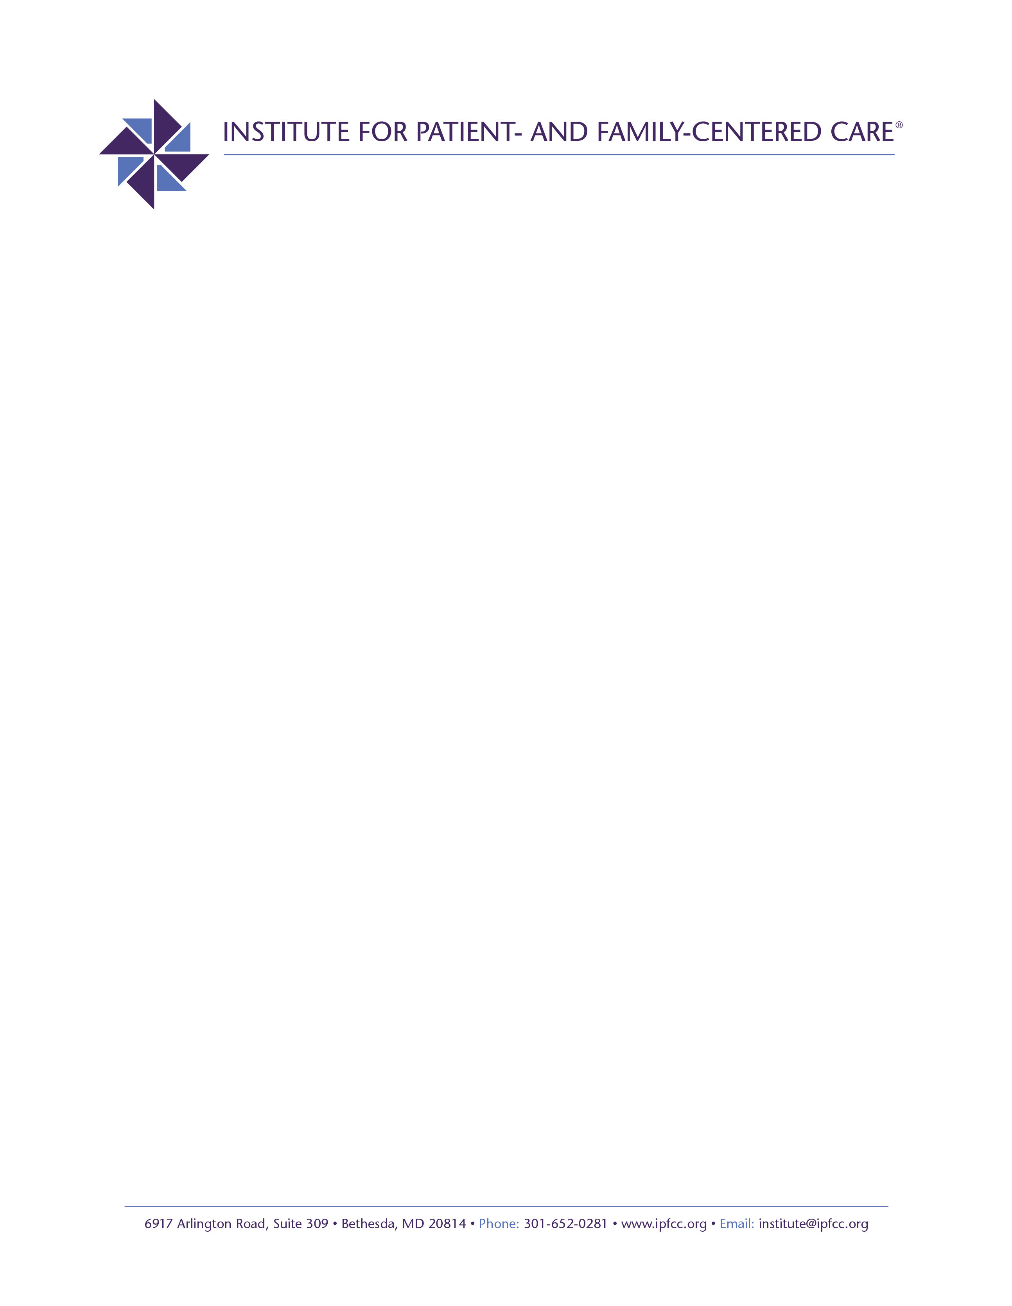

Patient- and Family-Centered Care and Pediatric Partnerships during COVID-19
Like other health care organizations, children’s hospitals and other pediatric programs are trying to manage the impact of the COVID-19 pandemic. Infants, children, and youth with special health care needs are at increased risk for complications from the virus and are facing disruptions in care. Children whose families experience inequities in access to safe, high quality health care are also very vulnerable. And, the longer term effects of the pandemic on children are potentially devastating.
Under these new and challenging conditions, committed staff and family advisors are wondering how to "stay true" to the principles of patient- and family-centered care (PFCC). They are seeking information about emerging best practices and resources providing practical guidance.
Funded by a grant from the Lucile Packard Foundation for Children’s Health, Palo Alto, California, the Institute for Patient- and Family-Centered Care (IPFCC) will lead a six-month project to serve as a resource and “clearinghouse” for up-to-date, easily accessible, information about ways to stay grounded in PFCC core concepts during COVID-19, while also prioritizing safety.
As part of the project, IPFCC will identify, develop, and disseminate information related to COVID-19 in pediatric settings. The information will be developed with and targeted to family advisors and Advisory Councils as well as health care professionals, especially leaders of PFCC, PFE, and psychosocial staff.
Key components of the project are:
- Scanning the field for pediatric best practices, strategies, and emerging concerns/issues related to PFCC approaches to the pandemic and partnerships with family advisors;
- Promoting virtual sharing and problem solving across organizations and regions through PFCC.Connect, IPFCC’s free online learning community and three free Informal Conversations;
- Disseminating information, emerging best practices, and resources quickly through three free webinars and other mechanisms.
The series of free webinars and online conversations will occur monthly from May through October 2020. The first three events are scheduled for May 26, June 25, and July 28 at noon EDT.
- To register for the May 26th Informal Conversation:
https://us02web.zoom.us/meeting/register/tZ0rdumprDwvG91FXyfA8niukC4mJbAenA-s

- For more information about future events, contact Deborah Dokken: ddokken@ipfcc.org

