Healthy Schools, Healthy Children
PROFESSIONAL DEVELOPMENT WORKSHOP
ENHANCE YOUR HPE PROGRAM

FRIDAY MARCH 13, 2026 9:00AM-2:00PM
BREAKFAST
BEGINS AT 8:30AM
Brigantine Community School 301 E. Evans Blvd.
Brigantine, NJ 08203



PROVIDED IN PARTNERSHIP BY
AND
An interactive workshop for K-12 health and physical education teachers!
Learn hands-on activities that will have your students active, and mastering content.


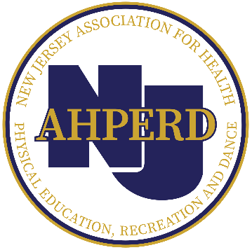

Healthy Schools, Healthy Children
PROFESSIONAL DEVELOPMENT WORKSHOP
ENHANCE YOUR HPE PROGRAM

\

PROGRAM SCHEDULE
 | Elementary – Gym A | Secondary – Gym B
Time
9:00AM-10:00AM | Title: In It to Win It!  Mark Housel  NJAHPERD & SHAPE America Eastern District  Physical Education  Teacher of the Year | Title: Teaching Mental Health in a Kinesthetic Classroom  Wendy Routhaul  NJAHPERD Middle School  Physical Education  Teacher of the Year
10:10AM-11:10AM | Nishuane’s Favorite Activities to do with Hula Hoops  Eric Eder  NJAHPERD Elementary  Physical Education  Teacher of the Year | Title: TBD  Chip Candy  NJAHPERD & SHAPE America Eastern District  Physical Education  Teacher of the Year
LUNCH - 11:10AM - 11:50PM
11:50AM-12:50PM | Title: TBD  Anna Potivin  NJAHPERD Adapted  Physical Education  Teacher of the Year | Title: Establishing Your PE Classroom Environment with 5 Simple Rules  Wendy Routhaul  NJAHPERD Middle School  Physical Education  Teacher of the Year
1:00PM-2:00PM | Title: TBD  Sean Pieseika  NJAHPERD Elementary  Physical Education  Teacher of the Year | Title: TBD  Chip Candy  NJAHPERD & SHAPE America Eastern District  Physical Education  Teacher of the Year

Register Here: https://www.surveymonkey.com/r/hpewksp2026

$40 per person (Check/PO only)
healthyschools@atlanticare.org
njahperd.org

