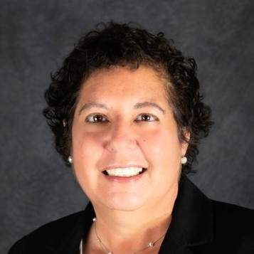
MEET DEBORAH FRIEDMAN
Born and raised in Shaker Heights, I still live there with my dog Beau and cat CC. I have four adult children, one son-in-law, and many grand-pets. I am a pediatrician by training with nearly 30 years of practice experience in northeast Ohio. I’m currently the chief medical officer for a Medicaid plan in Kentucky that supports foster youth.

I got involved with WMO because I was excited after meeting the WMO contingent at a national Women of Reform Judaism conference on social justice last spring. I plunged in headfirst as co-chair of the social justice committee. I’m thrilled to be helping to plan the WMO Day of Action, which is part of Women of Reform Judaism’s National Day of Action on April 12. Our plans for this day are beyond fantastic! I really enjoyed WMO’s Rosh Chodesh program.

When I am not working or volunteering or visiting with my children, I enjoy travelling, pickleball, Pilates, knitting, and spending time with friends.
~
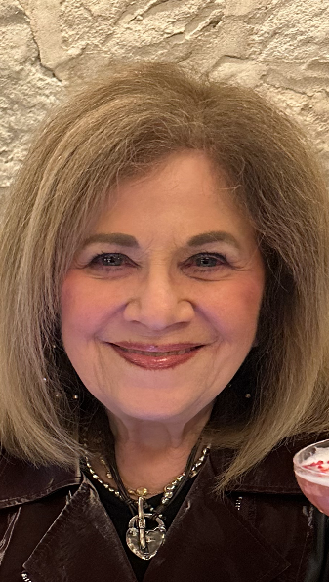
MEET SHELLEY GOLD GILMORE
I was born in Cleveland to wonderful parents who I was lucky to have had until 2022. I was raised with a lot of love growing up. We belonged to Heights Temple, where I was confirmed. Our family followed the holidays traditionally and this gave me a secure love for Judaism. I attended Ohio State University, where I majored in business. I then attended Dyke Business School, which prepared me for my career as a legal assistant and paralegal, from 1968-1998. During that time, I married and we adopted our daughter, who is now 50 years old, married, and lives in Colorado. I have two grandchildren who live in Cleveland. I developed a second career in the fashion business that I loved and worked at as a sideline and do to this day.
I raised my daughter on my own for 12 years before meeting my second husband, Alvin Gilmore, an attorney. After our marriage, I became his assistant in his law practice until Alvin passed away from Covid in 2021. Fortunately, Alvin was able to see me become a B’nai Mitzvah and was so proud of my achievement. We were married for 27 years. I am also fortunate to currently have a wonderful relationship with Gary, who I knew from high school.
Also, in my career path, I worked for Rabbi Klein and Rabbi Rosie Haim for three years as their assistant at The Temple Tifereth Israel. At that time, I was very involved with the sisterhood. I am very happy to see our new sisterhood at Mishkan Or becoming so strong, seeing younger women joining as we continue growing. I loved the Opening Dinner, Passover dinner, and Chanukah celebration. I am looking forward to our retreat in April and to more events as time goes on. Thank you to everyone for being a part of WMO!

