This is Us! October 2026 Pat Singer & Lindsey Walsh-Resnick
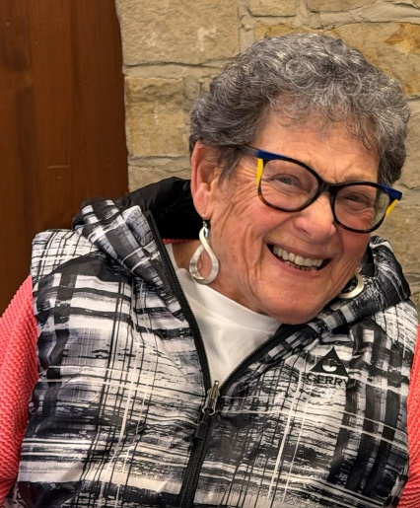
Meet Pat Singer
Eight decades plus six years ago, I was born in Youngstown, Ohio. Six months later my parents and older sister moved to Cleveland where I have lived for the rest of my life. I grew up in Cleveland Heights and graduated from Heights High School in January of 1958. I attended Kent State University, transferred to Tri-C with a two-year degree in Early Childhood Education. I continued my college education at Ursuline and finally graduated with a bachelor’s degree in education
I am now the head of the Singer Family which includes four adult children, two in-law children, six grandchildren, and four great-grandchildren. One daughter now lives in Cleveland, and the rest of the families live in the Chicago area, New York City, outside of Denver and Los Angeles.
Travel was one of the highlights of life for my late husband, Norm, and me. Over our 67 years together we were on all seven continents. They were wonderful experiences, especially our trip to Antarctica. My interests are sewing, quilting, knitting, reading, gardening, and volunteering.
Professionally, I taught pre-school at Ganon Gil for 10 years. At the same time, I taught fourth grade and the new 8th grade Family Education class at Anshe Chesed Fairmount Temple for almost 30 years. By this time, I was tired of teaching, so I went to work for my husband, installed his computer system and prepared tax returns for more than ten years.
It was again time to make changes in my volunteer life, so I joined Anshe Chesed Fairmount Temple sisterhood. My family, starting with my beloved Grandpa, were life-long members of Anshe Chesed Fairmount Temple. I was on the board for many years wearing many different hats. When the merger became a reality, I continued my volunteering by becoming a Women of Mishkan Or member. I soon became the Parliamentarian, which included being the chairperson of the committee writing the new set of by-laws and then chaired the new policy committee. I also wrote the job descriptions of WMO board officers.
2025 and 2026 have been difficult years for me. I realized it was time to resign as Parliamentarian and a Board member due to major care-giving responsibilities. It was a difficult decision but one that was in the best interest of my family and WMO.
As I look toward the future of WMO, I hope to see new and younger members discover the same sense of purpose and friendship that I've found through my years of service. I hope they grow into active board members, officers and committee chairs, bringing their own ideas, energy and enthusiasm to WMO.

After so many years of involvement, I am grateful for the friendships I have made, the experiences I have shared and the opportunity to contribute to an organization and community that has been such an important part of my life.
####

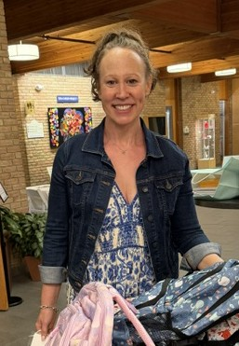

Meet Lindsey Walsh-Resnick
I was born in Niagara Falls, NY, and grew up in a teeny town called Middleport, New York. Today, I live in Beachwood with my husband, Greg. We have two children, our son Liam and our daughter Nora, who are both young adults. Family is incredibly important to me, and this stage of life—watching our children find their own paths while also having more time to explore my own interests—has been a meaningful one.
I earned my bachelor’s degree in Spanish and spent part of my professional life teaching Spanish to young children through programs in daycare and preschool settings and private tutoring from infant through adult. I loved being able to introduce children to another language and culture at such a young age. I am now retired, which has given me the opportunity to devote more of my time and energy to the things that are important to me, including family, community, volunteering, and Jewish life.
My involvement with Women of Mishkan Or grew naturally out of my desire to become more connected to our Jewish community. Judaism and Jewish community have become an important part of my life, and WMO offered me a place where I could not only participate, but also contribute.
The more involved I became, the more I appreciated the relationships, sense of purpose, and opportunities to serve others. I currently serve as Co-Vice President of Social Justice, a role that is especially meaningful to me because it allows me to help turn our shared Jewish values into action.
My favorite WMO program to date was the docent led trip to The Maltz Museum for the American Dream exhibit. What I especially enjoy about WMO programs is the combination of friendship, community, and purpose. I love seeing women come together—not simply to attend an event, but to also participate, volunteer, laugh, work together, and build relationships.
I would love to see WMO continue to find ways to bring women of different ages, backgrounds, and stages of life together. I hope we continue to create opportunities where everyone feels that there is a place for her—whether she wants to attend an occasional social event, participate in social justice work, learn something new, volunteer, or take on a leadership role.
I am particularly excited about continuing to grow our social justice efforts. There are so many ways that we can make a tangible difference in the lives of people in our greater Cleveland community while strengthening the relationships within our own community at the same time.
I love learning, traveling, staying active, and getting involved in projects that bring people together. At this point in my life, I have a real appreciation for community and for the importance of showing up. Some of the most meaningful relationships and experiences happen simply because we say yes—to an invitation, to volunteering, to meeting someone new, or to trying something we haven’t done before.
I’m grateful to be part of Women of Mishkan Or, and I’m excited to see where we go next.

