THIS IS US APRIL 2026
Ann Markoff & Ellen Klein
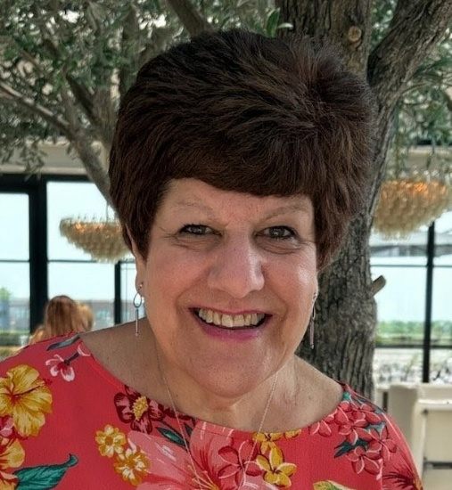
Ann Markoff
I am a proud graduate of Mayfield City Schools who never truly left! I started my career in Dayton teaching students with hearing impairments but soon returned to Mayfield. This is where I spent most of my career helping students with learning differences develop career skills as a Job Training Coordinator. I found great purpose in helping students bridge the gap between school and the workforce.
My husband, Mike, and I live in Highland Heights, and love having our two sons, their wives, and our adorable 5-month-old grandson close by in the Cleveland area. When I am not spoiling the baby, I love trying new restaurants, playing mahjong, attending the theater, and working on projects for NCJW/CLE and the Women of Mishkan Or.
Serving with the Women of Mishkan Or has been profoundly rewarding. Currently, I am Co-VP of Fundraising, and I am honored to help empower and shape the next generation of women leaders. The recent WMO Intergenerational Cookie Decorating Fundraising event at CMO was a highlight, fostering community connections and Jewish values. Thank you to all who have helped me build meaningful relationships at WMO.
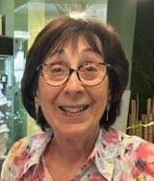
Ellen Klein

I jumped right in when our congregations merged. I planned a Women of Mishkan Or board potluck dinner that first summer; I wanted to meet some of the Tifereth Israel WMO board members. The co-presidents held a potluck before our second year. I hope that casual dinner will become a tradition. I look forward to participating in many more WMO activities and am looking forward to the Retreat in April.
Before retiring, I taught business subjects and served as the business education chairperson at Euclid High School. I loved my job especially since my students interviewed and worked in offices in the area — they earned high school credit and a paycheck.
When I retired from teaching, I joined the Fairmount Temple Sisterhood and soon was asked to serve on its board. I enjoyed serving on two other boards — Beachwood Arts Council and Friends of the Mayfield Library. Sisterhood is still my favorite activity. As a programming vice-president and then co-president with Iris Greene, I tried to find different programming for the afternoons and sometimes in the evening.
I still look in the community for interesting events to attend and then recommend them to our WMO programming committee. I also enjoy volunteering with National Council of Jewish Women, Cleveland.
I graduated from The Ohio State University with a bachelor’s degree in education and earned a master’s degree from John Carroll University.
I have been married to Alan for 58 years. We are parents to Stephanie, grandparents to Samantha and Amanda, and mother-in-law to Mark. We are looking forward to Samantha’s wedding to Adam Marcus this summer.

