THIS IS US

Diane Lavin
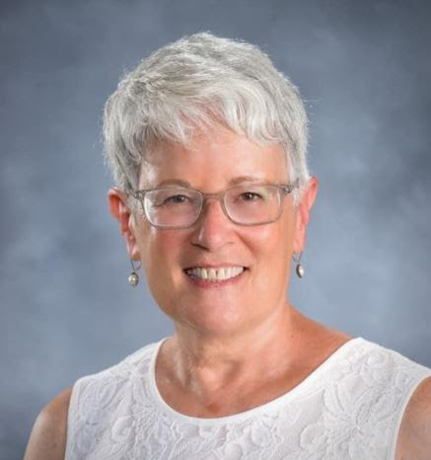

My husband Arthur and I were born in Canton, went to elementary and high school together, and married as college seniors almost 51 years ago.
We’ve raised three kids and have four delicious grandkids. Since our son and his family live in Hong Kong, we travel there as often as we can. Professionally, my heart and soul are in teaching.
My involvement in the Women of Fairmount Temple initially, and now in the Women of Mishkan Or, began and continues through teaching. I adore the courses I’ve developed for our group and the insightful, personally meaningful comments our members continually raise.
A special thank you to Phyllis Berlas and Ronna Kaplan for their constant support. I am also one of Laurenda Messer’s recruits - (Who can say no to Laurenda?) on the vest project.
Looking ahead, the book club and I are destined to link arms, and the Caring Community has my heart. For both, I hope to find more time to join in.
A few years ago, I learned to groom horses, and I’m also working on a historical fiction novel set in 1910 Tennessee. As I write this, I’m heading to the Smokies and Knoxville to meet my characters there and deepen my capacity to write their story.

Ronna Sherman
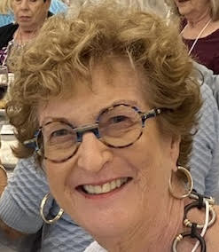
I am a lifelong Clevelander. I graduated from Heights High School, The Ohio State University, and Western Reserve University (CWRU). My husband and I raised two children. Now we have five grandchildren.
I have been an active volunteer with organizations since high school, including B’nai B’rith Girls, Junior Child Care, NCJW Cleveland Section, TWA, and now, Women of Mishkan Or.
I was fortunate to be on the transition committee when the two sisterhoods were merging. I immediately bonded with my new sisters. I am in awe of the many programs WMO offers. They are always welcoming, interesting, and well-received. I am honored to be part of the board.

