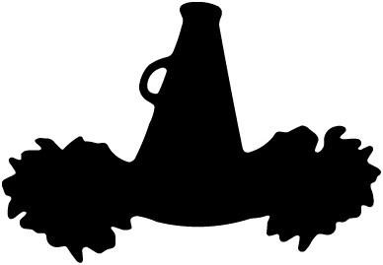
Mini Pantherette Clinic

OLP Cheerleaders are hosting a Mini Pantherette Clinic for girls, 3 years old - 2nd grade!

It’s only $30 to participate and includes the following:
New PANTHERS Spirit Shirt
Cheer Bow
Mini Pom Poms
Key Dates:
January 16th – Deadline to register!!
January 27th – Clinic at OLP Gym from 3:30 – 4:30 pm *
January 29th – Clinic review at OLP Gym from 3:30 – 4:15 pm *
January 31st – Catholic Schools Week Assembly Performance – 10:45am at OLP Gym*
Feb. 8th – 8th Grade Boys Basketball Game at St. Michael’s High School @ TBD

* Events on January 27th, 29th, and 31st – Cheerleaders will walk Mini Pantherettes from the ECC to OLP and bring them back to the ECC afterwards.
* Please join us 1/31 in the OLP gym for the performance and to see Bishop Johnston speak!
FILL OUT THIS FORM OR REGISTER ONLINE BY JANUARY 16TH!
Forms should be turned into the OLP or ECC front office or Online registration can be found on the OLP site under the Extracurricular tab (cheerleading sub-tab). Please direct all questions to olppanthercheer@gmail.com

STUDENT’S NAME:_____________________________________ TEACHER:_________________________________

PARENT’S NAME(S):____________________________________ EMAIL(S):____________________________________

Mini Pantherette Shirt
TODDLER | 2 | 3 | 4 | 5/6 | 6T
YOUTH (unisex sizing) |  | S | M | L | XL

Please include payment of cash or check (made payable to OLP Cheer) along with this order form.
You can also place your order online through the OLP school website.
REGISTRATION COST IS $30. DEADLINE TO REGISTER IS JANUARY 16!

