March 6, 2023

Dear Parents,

Over the next few months, your child will be participating in the administration of the GCPS Milestone Benchmark and the Georgia Milestone Assessments. I wanted to share information about each test so that you are aware of the purpose of each.

The GCPS Milestone Benchmark
For the 2022-2023 school year, GCPS has embarked on the task of developing a common district assessment that can be utilized to report on a student’s mastery of the grade level standards and to predict student performance on the state Milestones Assessment. The development of such Milestones Benchmarks will support schools in identifying students who have demonstrated proficiency on the standards that would likely result in a beginning, developing, proficient, or distinguished learner level on the Milestones. Such information enables schools to identify students who need re-teaching of standards and concepts to address student learning needs.

The GCPS Milestone Benchmark will be given on Friday, March 10th and Monday, March 13th. Sixth and seventh grade students will take the Milestone Benchmark in Language Arts and Math. Eighth grade students will take the Milestone Benchmark in Language Arts, Math, Science, and Social Studies. The Milestone Benchmark test will count 5% of the student’s overall grade.

The Georgia Milestones
The Georgia Milestones is a comprehensive summative assessment program that measures how well students have learned the knowledge and skills outlined in the content standards. It is designed to provide information about student achievement and readiness to move on to the next level of learning. While the tests measure each individual student’s mastery of the curriculum during the school year, they also help teachers and schools better identify what resources and support our students will need in the coming school year.

The Georgia Milestones End of Grade Assessments will be given to students in grades 6-8 to measure achievement in Reading, Language Arts, and Mathematics. Students in 8th grade also are assessed in Science and Social Studies. In addition, any student enrolled in Algebra I is required to take the Georgia Milestones End of Course test. The Algebra I EOC is the only test that counts as a grade, and it counts 20% of the student’s overall grade.
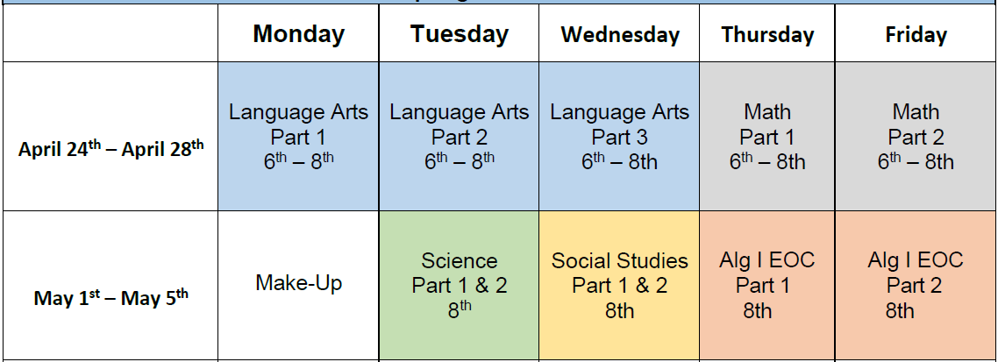

To the right is the schedule for the Georgia Milestones Assessments. If you have any questions regarding these tests, please reach out to your child’s teacher or contact our testing coordinator Jeff Harrison at Jeff.Harrison@gcpsk12.org.

Sincerely,
Ryan Queen
Principal
Trickum Middle School

