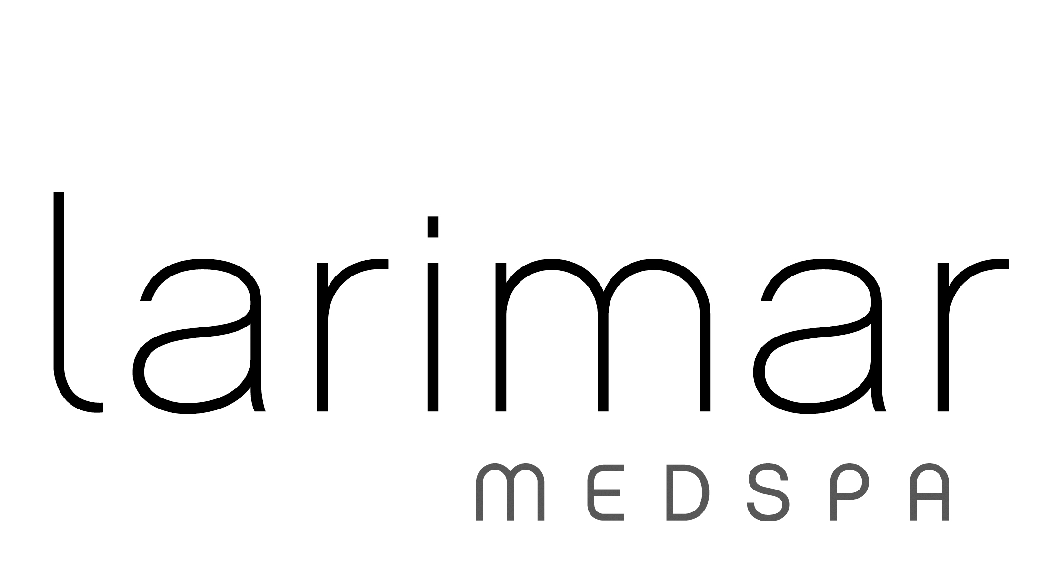
Sciton Forever Clear BBL® Acne Treatment
Forever Clear BBL® uses a combination of blue, yellow, and infrared light to eliminate bacteria, reduce inflammation, and promote the body’s natural healing process to clear acne.
Treats the following conditions:
- Mild to moderate pustular inflammatory acne vulgaris and associated redness
Ideal Areas Treated:
- Face
- Neck
- Chest
- Back
For optimal results, 6 treatments are recommended at intervals of 2 week.
- Localized redness and swelling may be present and typically resolves within 24 to 72 hours.
- With any laser treatment, it is best to avoid sun exposure two weeks prior to treatment, during the course of treatment and after treatment’s are complete. Unprotected sun exposure may or may not have contributed to your condition, but it can certainly affect your results. Remember, all natural light causes sun damage and UVA is present all day long, through window glass and clouds.

Larimar Medical, PLLC
307 Manufacturers Road, Suite 201
Chattanooga, TN 37405
(423) 755-8880 larimarmedspa.com
Sciton Forever Clear BBL® Acne Treatment
Fee Schedule
Area | Package (6 treatments)  = 15% Discount | Single Treatments
Face | $1530 | $300
Neck | $1020 | $200
Chest | $1785 | $350
Back | $1785 | $350

Multiple Area Discount:
Receive an additional 15% off equal or lesser priced area
(includes single treatments and packages)

