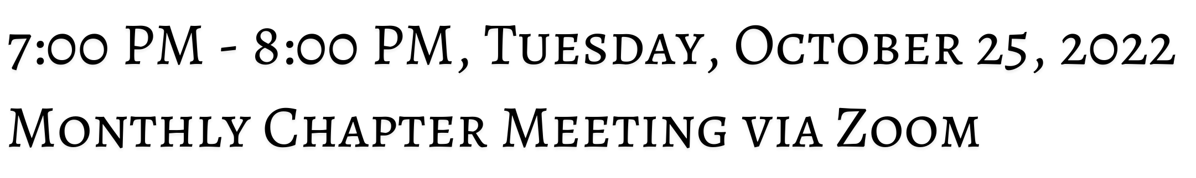

Beginning in January 2023, our Monthly Chapter Meetings will be held on the last Tuesday of the

month from 7:00 PM - 8:00 PM via Zoom. Quarterly in-person meetings/events are TBD.

if you would like to host at your congregation or register for events, please email infoubechi@gmail.com.





The Union of Black Episcopalians stands in the continuing tradition of more than 200 years of

Black leadership in the Episcopal Church.

