Upcoming Demo Days at
Cottonwood Driving Range

Cleveland/Srixon – Wednesday March 11th

Cobra – Wednesday, March 18th

Callaway - Wednesday, March 25th

TaylorMade – Wednesday, March 25th

CONTACT THE GOLF PRO SHOPS FOR MORE DETAILS. SIGN UP LINKS WILL BE SENT OUT APPROXIMATELY ONE WEEK AHEAD OF EVENT.


Both Cottonwood and Palo Verde have moved to Golf Genius for our tournament software. This allows us to do on course scoring throughout the round with the assistance of a smartphone. The Golf Genius app can be downloaded in your app store for either Android or Apple. All signups for all leagues will be done through the Golf Genius moving forward. Emails will be sent out each week for the next event. Simply click on “Playing” if you would like to play, verify and acknowledge your information is correct on the next screen, and click “Sign Up.” If unable to play, either disregard the email or click on “Not Playing.” In cases where you can pick your partner, foursome, playing time, etc…follow the prompts after selecting “Playing” and enter any information.
CLICK HERE to learn how to download and use Golf Genius in your upcoming league round.



UPCOMING GOLF COURSE EXCEPTIONS:
- SATURDAY 3/7 – CMGA MEMBER/GUEST – COTTONWOOD CLOSED ALL DAY
- SUNDAY 3/8 – CMGA MEMBER/GUEST – COTTONWOOD CLOSED ALL DAY
- SUNDAY 3/15 – PVMGA CLUB CHAMPIONSHIP RD #2 – PALO VERDE – SHOTGUN START – AM CLOSED FOR EVENT

FOR MORE INFORMATION, PLEASE REACH OUT TO THE COTTONWOOD GOLF PRO SHOP




Just In
from PING!
G440K Driver & S259 Wedges

Available now at the Cottonwood Pro Shop

JONAS INFORMATION

NOTE!! IF YOU ARE NOT RECEIVING EMAIL NOTIFICATIONS FOR YOUR TEE TIMES, PLEASE REACH OUT TO EITHER GOLF SHOP!!

ALSO, IF YOU HAVE MORE THAN ONE PROPERTY IN THE COMMUNITY, PLEASE MAKE SURE THAT YOU ARE PUTTING IN THE CORRECT NAME WHEN MAKING TEE TIMES. YOUR MEMBERSHIP IS TIED TO THE HOMEOWNER CARD NUMBER PRESENTED WHEN RENEWING. IF YOUR GROUP SELECTS THE WRONG NAME, IT MAY AFFECT WHETHER YOU GET YOUR REQUEST OR NOT. PLEASE REACH OUT TO EITHER GOLF SHOP IF YOU HAVE ANY QUESTIONS.

Both golf courses have moved to the Jonas Tee Time Reservation System as of Monday, December 1st!!
The first step for all golfers and homeowners is to register on our new website: www.cottonwoodpaloverde.com. In order to be put into requests, all golfers MUST register. Please follow steps below. If you need help with registration, please contact the Cottonwood or Palo Verde Golf Pro Shops and we will gladly assist you.
Select “Member Login” located in the upper right corner of the homepage. You will be taken to the screen shown below.
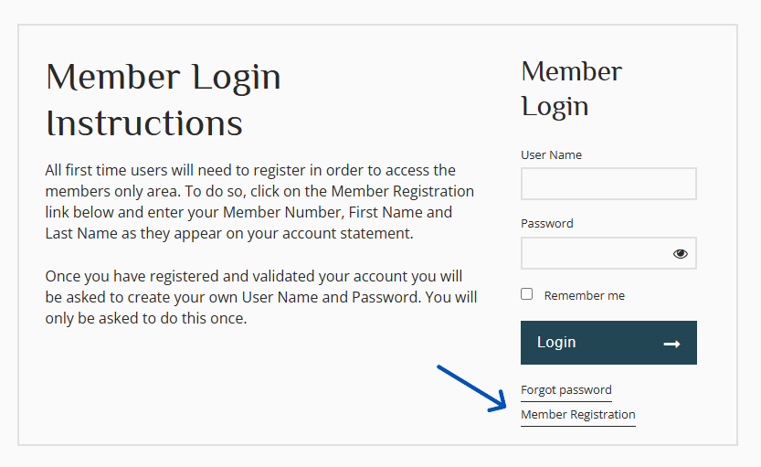
Choose “Member Registration” and follow the prompts. You will need your Member Number (found on the front of your homeowner card) and the exact spelling of your name as it appears in HOA records. This may or may not match what is on your homeowner’s card. This could include formal names, middle initials and the like. If you aren’t sure of how your name is logged or of your member number, please contact either Golf Pro Shop for assistance.
Once you have registered on the website, you may then download the App through your Google Play Store or Apple App Store. Search for “Clubhouse Online.” You will use the same login information that you used to register on the website to login in the app.



Once you’ve set up your username and password on the website, you can begin entering tee time requests and bookings through either the Clubhouse Online app or the Cottonwood Palo Verde website. Note: The Clubhouse Online is a mobile app only. Please do not go to the clubhouse online webpage. All requests/bookings can be made on our website www.cottonwoodpaloverde.com as shown below.
To get started, go to the Golf tab and select Tee Times. Here, you’ll find the available tee times and hole assignments for each day. Tee sheets will be posted seven (7) days in advance, excluding gender-designated days. After the lottery draw is completed, homeowners can log in to book any available times. You can also make future tee time requests in the same section. Requests may now be submitted between 7 and 14 days in advance.
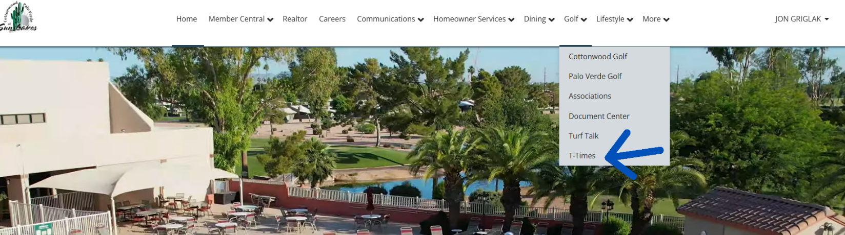

When making a request, simply select the date you wish to play and enter the required player information. We encourage all homeowners to log in and explore the new system—try making a booking or submitting a request to get comfortable with the process. Please note, you will no longer be able to select a second course option when making requests.
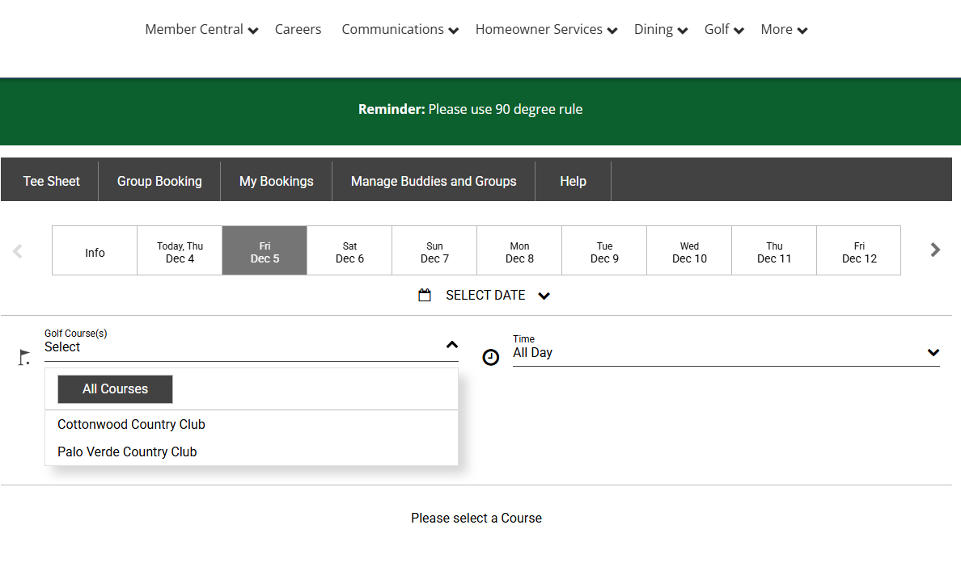
You can only make requests for Cottonwood OR Palo Verde, but not both. For instance, with Chelsea, you were able to select Cottonwood as your first option, and Palo Verde (or vice versa) as a second option in case you didn’t get into your first option. With Jonas, if you want to have a fallback option in case you do not get your 1st choice of golf courses, you will need to put in two (2) separate requests. One for each course.
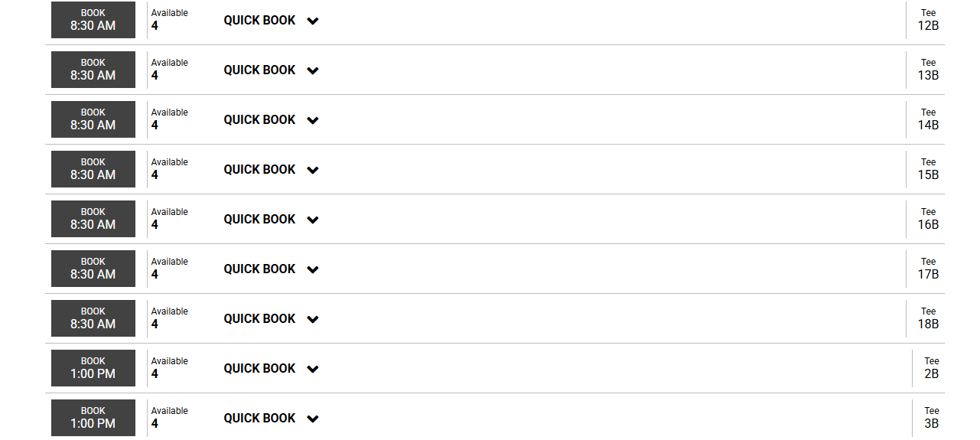
The above picture is a screenshot of a tee sheet you would see either in the app or on our website (www.cottonwoodpaloverde.com). Anytime you see “Quick Book,” that means that that day is open and that tee time/hole assignment is available for any homeowners to book. Simply click on the black box with the time on the left of the screen. Note the hole assignment (shotgun starts) on the right side of the screen. You may also select Quick Book and select the number of players in your group or add a group booking (if you have them set up).
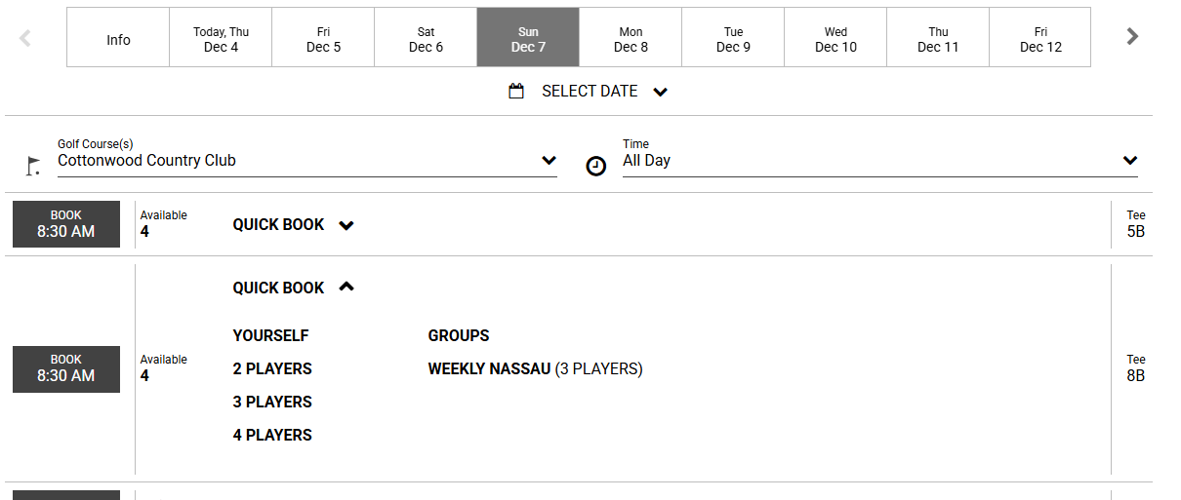
Notice in the above picture, I selected the Quick Book button. I can now select the number of players or add my “weekly Nassau” group that I have set up in “Manage Buddies or Groups.” Simply select the appropriate option and you will be directed to this next screen below:
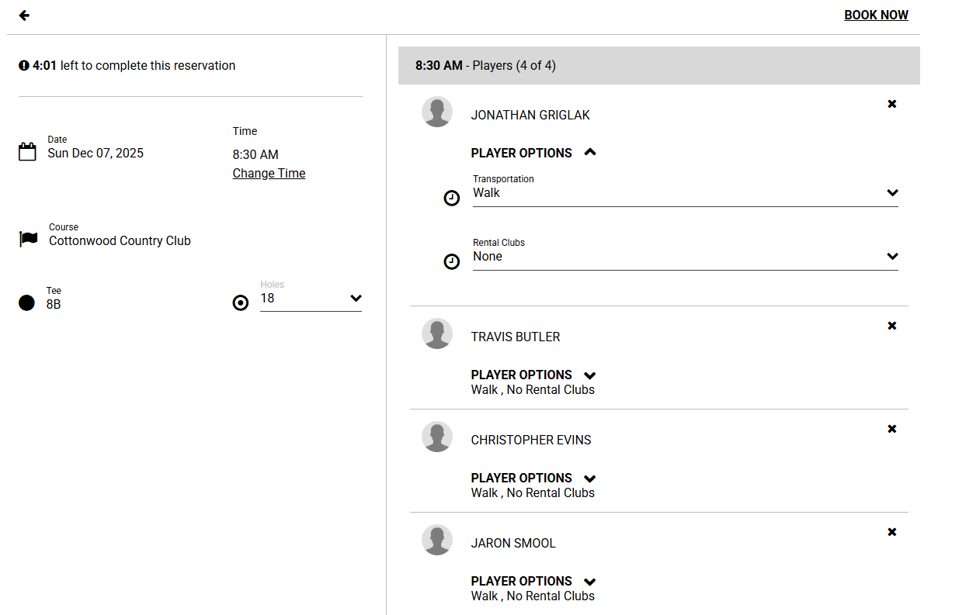
There are a few things to note. First, in the upper left-hand corner of the above image, you will see a timer. You will have 5 minutes to complete your group. If the timer starts to run low, don’t panic. A prompt will pop up asking if you need more time to complete your booking/request.
Next, I have selected “Player Options” under player 1. Here I can request a cart as well as rental clubs if either are needed. Simply hit the down arrow on the right and select what you will need. The default is “walking.” We realize not many of our homeowners walk, however we didn’t want any confusion with those needing a rental cart from either golf shop. Please do not select rental cart unless you need to rent a golf cart for your players. Also, please make sure to add a rental cart to ALL players that will be using the rental cart.
Third, for this group I selected my “weekly Nassau” group. Just because I have a set group of consistent players that play every week, doesn’t mean that I can’t edit that group. Click on the “x” on the player you’d like to remove, and then add a member, guest, tbd, or buddies & groups.
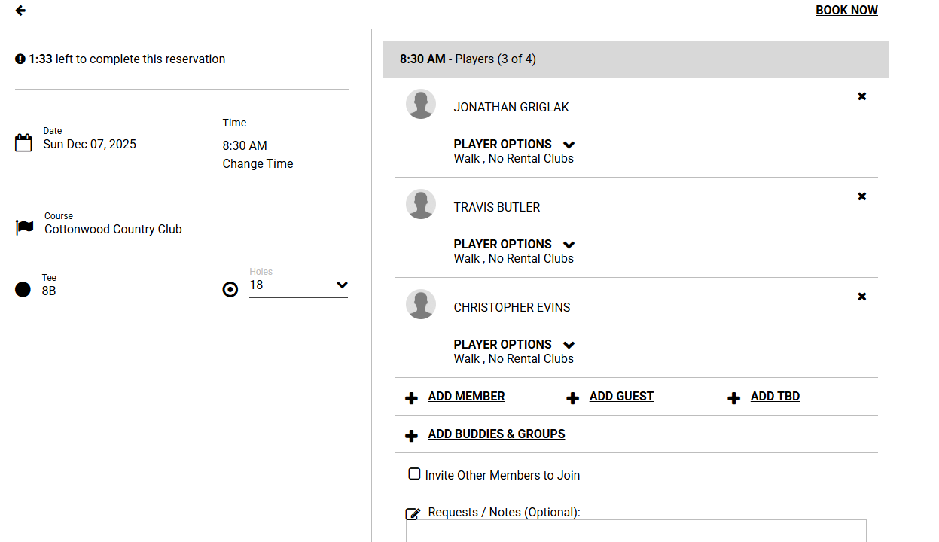
Note: All homeowners, whether they purchase an annual membership, Homeowner’s Play Card, or no membership, are considered members. Anyone outside of Sun Lakes would be considered a guest.
Below is a list of videos to help you with making your bookings, requests, and groups as well. You can also find these on the black bar of the tee time page as well under “Help.” If you have any questions regarding how to enter your groups, please come to the golf shop and we’ll happily guide you through.
HOW TO BOOK A TEE TIME
HOW TO BOOK A TEE TIME – MOBILE VIEW
HOW TO EDIT AND DELETE A TEE TIME
HOW TO BOOK A GROUP TEE TIME
HOW TO MAKE A LOTTERY REQUEST
HOW TO MAKE A LOTTERY REQUEST – MOBILE VIEW
HOW TO MANAGE BUDDIES & GROUPS
HOW TO MANAGE BUDDIES & GROUPS – MOBILE VIEW
MY BOOKINGS
MY BOOKINGS – MOBILE VIEW
We appreciate your patience as we transition to this updated system. If you experience any quirks or issues, please notify either golf shop so we can ensure a smooth rollout from day one.

How Will Jonas Operate?
Using Jonas and Chelsea will be very similar in several ways but different in a few ways as well.
The Same:
- The priority system will remain the same. Groups consisting of 2, 3, or 4 members of the various types have the following priority:
  - Level 1: Combo/Combo with Range
  - Level 2: CW Only/Range & PV Only/Range
  - Level 3: Homeowner Players Card
  - Level 4: Guests
  - Level 5: Non-Annual Homeowners

The group will have the priority of the lowest ranking player in group. For instance, a foursome made up of three (3) Combo members and one (1) CW Only member will have Priority Level 2 for their request. Meaning a group of 2, 3, or 4 members that are all Combo/Range members will have priority ranking ahead of that group in the lottery draw. Linked groups of 8, 12, 16, etc.... players will also take the priority level of the lowest ranking player in the entire group. Meaning if a linked request of 8 members is put in, with 7 Combo members and 1 Homeowner Player Card member, both linked groups will be at Priority Level 3. This system is the exact same as what we used on Chelsea for the past two seasons.

- The Point System remains the same. Within each of those levels, priority for groups with the same Priority Level will be determined by the point average for the group. A point is assigned to each player each time they play. They are assigned an additional point for each guest that is linked to their name. For instance, if I play on a Monday and I have 3 guests, I will gain 4 points for playing that day. These points are accumulated over the week prior to the draw date and averaged among the players in your group. If player 1 has 3 points, player 2 has 2 points, player 3 has 4 points, and player 4 has no points, the group will have an average of 2.25
3+2+4+0 9
2 2 =2.25
his average will then be compared to the groups with the same priority level with the lowest average of the groups being placed first. This calculation is performed for each priority level to develop the tee sheet each day.

- Buddy List: Just like in Chelsea, you can add other homeowners into your buddy list to help make inputting your requests and bookings easier. The one addition is that you can also add guests into your buddy list in case you have a guest that frequently plays with your group!

Different:
- New website and new app!! Building a new website has allowed us to bring much of our community into one location. The golf tee time software is now available on our community website for both Cottonwood and Palo Verde Golf. Go to the golf tab, click on make a tee time, and fill out the necessary information on one screen. You no longer have to worry about going to the right location, instead now you just need to go to the date you are looking for and input your groups. You’ll know it’s a request because every available slot will say “lottery” in the player boxes.

- Now we will have tee sheets seven (7) days in advance! Instead of three (3) days like we currently use, the lottery draw will be performed seven (7) days ahead of time. Meaning; the lottery draws for Monday, December 1st will be performed in the afternoon of Monday, November 24th. During the winter season, the draw will be done approximately around 1:00 pm each day and approximately at noon each day during the summer season.

- You can now add rental carts and clubs to your request! All homeowners will default to “walking” even though we know most of you do not walk the golf course. If you or your guests need to rent a golf cart from either shop, make sure to change the status for you or your guests from “walking” to “rental cart” to ensure we have a cart available for you that day. Same goes for rental clubs. Click the drop-down menu for the player that needs rental clubs and select the setup they will need for that day.

- All league signups will now be done through a sign-up sheet (only for certain events) or invites from Golf Genius for each round. There is no event request in the Jonas program. All members of CMGA, CLGA, PVMGA, PVLGA, and PVCL will be sent out invites a week or more prior to the actual event. From these invites, you can select “playing” or “not playing.” If not playing, you can also just ignore the email. If you select that you would like to play, you will be redirected into the league portal and once there can confirm your information as well as add any additional players or answer any further questions pertaining to that event (if applicable). For more information, please see either golf shop.


CLICK HERE
TO SEE THE CURRENT
HOMEOWNER GOLF CART POLICY


Click Here
For the latest AAG Golf Advocacy Update


“TURF TALK”
BY: SCOTT ANDERSON- Director of Agronomy
FIND OUT WHAT IS NEW AND INTERESTING
WITH OUR GOLF COURSES!
CLICK HERE
TO READ THE WEEKLY REPORT


BOTH PRO SHOPS REGRIP CLUBS!
-------------------------
Putter grips are also available!
Call or stop in for pricing

DRIVING RANGE POLICY
CLICK HERE TO VIEW THE FULL POLICY


The Cottonwood Driving Range is available to use by all Sun Lakes homeowners and guests. Tokens are available for sale in the Cottonwood Pro Shop. The range closes early on Monday afternoon at 3 pm for maintenance, otherwise it is open 7 days a week, from dawn until dusk. All range patrons must adhere to the dress code. Baskets and golf balls should NOT leave the range area under any circumstances.


BOTH COURSES ARE ON THEIR WINTER SCHEDULES.

Cottonwood
Cottonwood runs shotguns 5 days a week
Monday, Thursday, Friday, Saturday, & Sunday
Shotguns start at 8:30 am & 1:00 pm

Tee-Times 2 days a week
Tuesday & Wednesday
Tee-times start at 7:30 am

Palo Verde
Palo Verde runs shotguns 4 days a week
Monday, Tuesday, Friday, & Saturday
Shotguns start at 8:30 am & 1:00 pm

Tee-Times 3 days a week
Wednesday, Thursday, & Sunday
Tee-times start at 7:30 am



REMEMBER TO USE THOSE SAND BOTTLES!
PLEASE FILL DIVOTS THROUGHOUT THE ENTIRE GOLF COURSE WITH EXCEPTION OF THE TEE BOXES -THE MAINTENANCE STAFF WILL FILL THOSE



PLEASE STOP BY EACH GOLF SHOP TO PICK UP YOUR EMERGENCY PROTOCOL STICKER!


CLICK HERE TO MAKE SURE YOU ARE
FIXING A BALL MARK CORRECTLY.

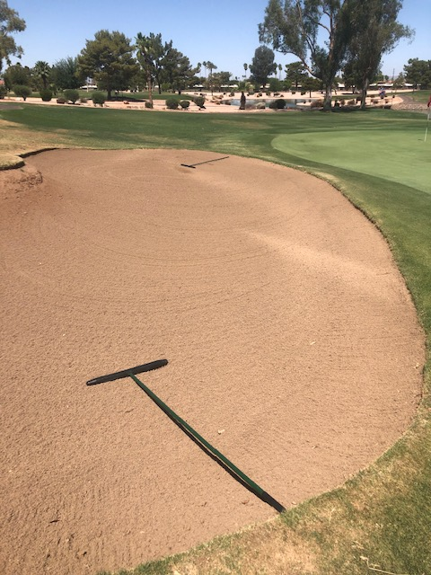

THE CORRECT RAKE POSITION AFTER
YOU ARE DONE RAKING

What is the proper attire/dress for playing golf?
Proper dress applies to those playing and/or using any of the practice facilities including the driving range, chipping greens, and putting greens. Men may wear pants, or golf shorts no shorter than mid-thigh. Men MUST have a collared shirt with sleeves. Mock turtlenecks or turtlenecks are permitted. Absolutely NO collarless shirts, tank tops, tennis attire, swim wear, or athletic shorts are allowed. Denim pants, shorts, and shirts (regardless of color) that are uniform in color, do not have holes or tears and are not frayed or raveled are permissible.
Women may wear slacks, or shorts/ skorts/skirts no shorter than mid-thigh. Collarless and/or sleeveless shirts, blouses, sweatshirts, and sweaters are allowed. Athletic shorts, swim wear, cut-offs, midriff-exposing tops, halter tops, revealing tank tops, and tennis attire are NOT considered proper dress for golf. Denim pants, shorts, and shirts (regardless of color) that are uniform in color, do NOT have holes, or tears, and are not frayed or raveled are permissible.
All participants MUST wear shoes. Cottonwood and Palo Verde golf courses are soft spike ONLY facilities. Metal golf spikes are NOT permitted. Golf shoes, golf sandals, sneakers or rubber-soled shoes MUST be worn on the courses and practice areas. Any footwear that would damage the greens is strictly prohibited.



Problem on the golf course? Who do I call?
When you observe a violation such as someone using the golf course as a practice facility during the hours of 7a.m.- 1p.m., please call the Cottonwood Pro Shop at 480-895-9449 or Palo Verde Pro Shop at 480-895-0300 depending on what course the problem exists. If there is a perceived violation on the golf course after hours, please call Patrol at 480-895-9277. Let's keep our courses the best in Sun Lakes.
Thank you for your help!
SOME VERY IMPORTANT THINGS TO REMEMBER TO HELP KEEP THE COURSE IN GREAT SHAPE THROUGHOUT THE YEAR

PLEASE ABIDE BY THE 90 DEGREE CART RULE AT ALL TIMES (when not cart path only)

PLEASE KEEP UP WITH THE GROUP
IN FRONT OF YOU- NO GAPS

HEAD TO THE CART PATH BEFORE YOU PASS THE YELLOW STAKES ON ALL
THE PAR 4’S & 5’S – KEEP THE GREEN SURROUNDS PLAYABLE

PLAY READY GOLF AT ALL TIMES

FIX YOUR BALL MARKS ON
THE GREENS

FILL ALL OF YOUR DIVOTS
THROUGHOUT THE GOLF COURSE

PRO SHOP HOURS

COTTONWOOD
November 3rd – April 30th 7:00AM-5:00PM

PALO VERDE
October 29th – April 30th 7:00AM-5:00PM

