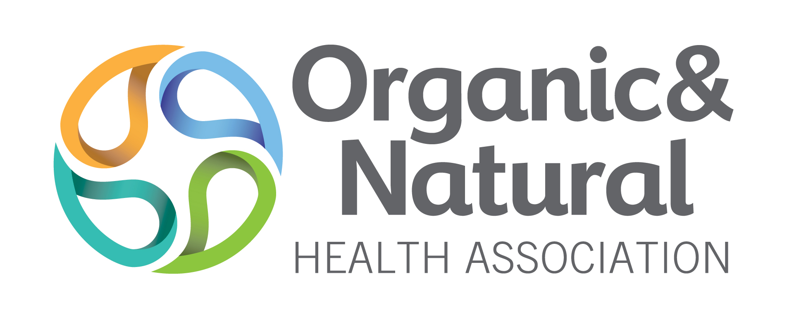
Glyphosate Voluntary Testing Program - O&N Members Only
FAQs
Q: What is glyphosate?
A: Glyphosate is an herbicide that is widely used on crops for weed control. It is the active ingredient in Monsanto Roundup® and other brands. Many genetically engineered (GMO) crops are genetically engineered to be resistant to glyphosate. Glyphosate is also used on many crops as a desiccant; this means it is applied in massive quantities to all kinds of crops just before harvest – to dry them out and prevent mold.
Q: Why is O&N focused on glyphosate?
A: O&N is leading efforts to measure and monitor all herbicides, pesticides, antibiotics, hormone disruptors, etc. in foods and supplements. O&N members want to participate in this effort. O&N is starting with glyphosate because it is of immediate interest and concern, and methods for its detection are available. ONA will over the years add to this.
Q: Am I required to have my products tested for glyphosate?
A: This is currently a voluntary program, but all members are strongly encouraged to participate.
Q: Why would I want to test if my products contain glyphosate?
A: So that you can help to address contamination in the supply chain for foods and supplements. Members join O&N in part because they are interested in helping industry improve the supply chain.
Q: Who chooses the products and how many of my products are tested in this program?
A: One product is chosen by the member in consultation with O&N staff for testing every year.
Q: How should I choose my product?
A: Here are some suggestions for consideration:
- It is expected that glyphosate contamination if present will be found in all kinds of crop or herbal based products because of the ubiquitous nature of glyphosate, run-off from adjacent farms, carry-over in the air etc.
- Choose a product you make or sell based on its importance to you and the general food supply chain. A commonly or importantly used ingredient or product is much more useful than an esoteric herb.
- Choose an ingredient or product where you are able or willing to dig deeper to find the source of contamination, if it is present
- Sometimes the source of the contamination may not be in the primary ingredient, but in processing aids, water, other excipients, etc. Choose an ingredient or product where other ingredients or products follow the same pathway – so that solving one contamination issue may solve this problem for many products
Q: Still not sure which product to choose?
A: O&N will be happy to help you with this decision.
Q: If I test my product and find contamination is this all that is required?
A: Remember that the purpose of this testing program is not just to determine if contamination exists, but then if it does, to dig deeper, test further, go back in the supply chain, to find the source and fix it.
Q: What does this mean?
A: O&N and HRI Labs will recommend investigation and further testing to help identify the source of the contamination, and members are encouraged to pursue this.
Q: Where is this testing done?
A: HRI Labs, Fairfield, IA will be conducting the testing
Q: Who pays for the test?
You, as a member, provide a verified sample and pays for the test.
Q: What does the test cost?
A. The cost for Glyphosate Testing by LC-MS/MS is as follows:
O&NHA Member price (includes 20% discount)
$140 per standard sample
$180 per complex sample

Q: Who sees the results?
A: Only HRI Labs, you the member and the Executive Director of O&N are privy to the individual results. (In year one, the Executive Director will only receive blinded results.) The BOD and other members do not see individual results, but they will be provided general trends, etc.
Q: If my product is tested and found to be contaminated with glyphosate, does this mean I’ll be booted from O&N?
A: At this point testing and subsequent corrective action is not a condition for membership but it is voluntary and highly encouraged. Positive test results will only help the member to improve their products and also help the food and supplement supply chain.
Q: If my product is free of glyphosate contamination, can I market this?
A: You are certainly free to use this information in any way you please but you should not use O&N’s name without its permission.

