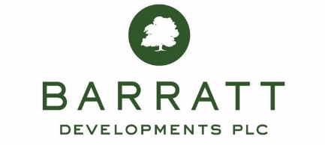

PRESS RELEASE
22 May 2020

THE BIG BARRATT THANK YOU TO NHS WORKERS

To say thank you to all NHS employees working hard to look after people during the COVID-19 crisis, Barratt Developments has launched a new NHS Deposit Contribution Scheme giving a 5% deposit to help them buy a new home.

The new scheme is a way of offering a heartfelt thank you to the country’s 1.5m NHS workers who will now be able to receive up to £15,000 towards buying any new Barratt or David Wilson home, including those available in Hounslow.

Barratt is also making the scheme available to people who have recently reserved a home but not yet completed, so that as many NHS workers as possible can benefit from the new deposit contribution.

The NHS Deposit Contribution scheme launched on Saturday 23 May and will run until the end of December 2020. This new scheme follows a similar contribution scheme available for the country’s Armed Forces launched by Barratt last month.

Barratt has been working hard throughout the coronavirus crisis to support the NHS. It donated £100,000 to NHS Charities Together and a further £50,000 to The Sun’s Who Cares Wins campaign, providing help for frontline NHS staff. It donated more than 5,000 medical-grade facemasks to hospitals across the country and gave its entire stock of 400 defibrillators to St John Ambulance in England and Wales and St Andrew’s First Aid in Scotland.

David Thomas, Chief Executive of Barratt Developments, said: “We want to say a big thank you to our brilliant NHS workers who have shown such courage in the face of the COVID-19 crisis. This is why we are announcing this new NHS deposit contribution scheme to thank them for all they have done.”

For more information on both the NHS Deposit Contribution Scheme and booking a sales appointment on specific developments, visit www.barratthomes.co.uk

NOTES TO EDITORS

For further information about Barratt Developments PLC, please contact Derek Harris on dharris@barrattplc.co.uk

About Barratt Developments PLC
Barratt Developments PLC sold 17,856 homes in the year to June 2019, making it the biggest housebuilder by volume in Britain. Over the past six years Barratt has increased its housing output by 40% - building more of the homes the country needs. Barratt is committed to building quality homes and received more NHBC Pride in the Job awards than any other housebuilder in 2019 and this year retained its HBF 5 star rating for customer satisfaction for 11 years in a row. For more information visit www.barrattdevelopments.co.uk

