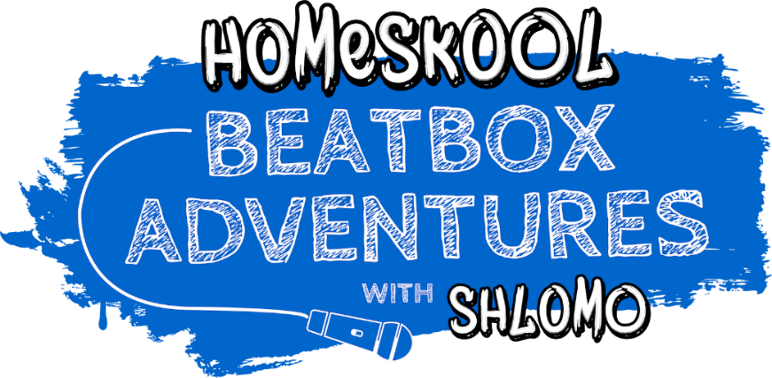
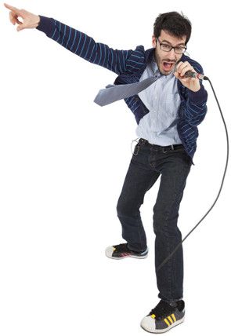

Dates: Weekly from Thursday, 7th May
Time: 2.00pm (BST)
Link: beatboxadventures.com

“SETS YOUNG IMAGINATIONS ALIGHT” ★★★★ The Times
Record-breaking beatboxer SK Shlomo is launching a huge project to help kids and raise money for NHS Charities Together.
Homeskool Beatbox Adventures is a weekly livestreamed interactive show empowering kids and their families to find their true voices and create their own music.
For 30 minutes every Thursday, families around the world will learn new vocal skills from SK Shlomo, the critically acclaimed world-champion beatboxer who has previously collaborated with Bjork, Ed Sheeran and Lily Allen, played at Glastonbury and broken world records with his jaw-dropping vocal gymnastics. Inspired by the success of his critically acclaimed tour show, Shlomo’s Beatbox Adventures For Kids, he wants to teach families in quarantine how to become Superstar Beatboxers and has set up a JustGiving campaign to try to raise £2500 for NHS Charities Together in the process.
“MESMERISING!” ★★★★★ Primary Times
Each week SK Shlomo will set families creative challenges to raise money by sharing performance videos of their new skills using the hashtag #beatboxadventures. Over the course of the 6 weeks, the Homeskool Beatbox Adventures community will create an anthem of their own, with its own music video featuring hundreds of families worldwide singing, beatboxing and performing together to celebrate music and to support the frontline workers on whom we all rely so much during this difficult time.
“It’s a show about believing in yourself.” says Shlomo “Finding confidence in your own voice is extremely empowering. That’s even more important when so many of us are feeling disconnected - we don’t know how we can help the world. This project can bring people together, connect the world up and raise funds for the heroes on the frontline who we appreciate so much.”
“SUPER MEGA AWESOME” ★★★★★ Deadline News
In order to involve as many families as possible SK Shlomo has partnered up with over 80 music venues and theatres to simulcast the free weekly educational show on their digital platforms to thousands of homes worldwide. He will also be joined by one of his talented friends each episode including Bastille, KT Tunstall, Bill Bailey, Basement Jaxx, Jason Mraz and BBC Radio 1’s Dr Radha.

www.skshlomo.com | skshlomo | @skshlomo | skshlomo

For further information and images or to arrange an interview with SK Shlomo please contact:
Paul Sullivan on 01932 570 582 or 07881 885 253 or by email at paul@paulsullivan.info

Notes to Editors

About SK Shlomo
SK Shlomo is a world record-breaking beatboxer who makes all kinds of music using just his mouth and a mic.
A drummer and percussionist from the age of 8 years old, SK Shlomo developed his beatboxing talents in response to restrictions on how often he could practise his beloved drums. These breathtaking vocal skills gained him early recognition as an internationally acclaimed beatboxer.
SK Shlomo first burst into the mainstream after appearing on BBC2’s Later… With Jools Holland, collaborating with Björk and performing with famous fans from Damon Albarn, Lily Allen and Jarvis Cocker to Imogen Heap, Martha Wainwright and Rudimental.
He soon became the first ever World Looping Champion and taught his friend Ed Sheeran some tricks. SK Shlomo became Artist in Residence at London’s Southbank Centre, played the main stages at Glastonbury, won rave reviews for his autobiographical one-man shows and even became the subject of an award-winning feature documentary, The Beatbox Choir.
But everything changed at the age of 27 when he became a father. Frustrated and exhausted by late nights on the road, SK Shlomo started thinking about ways to teach his skills to the younger generation and began touring a family show called Shlomo’s Beatbox Adventure For Kids. The show became a phenomenal success, with five star reviews and sell out shows from the Royal Albert Hall to the Edinburgh Festival.
Since 2017 SK Shlomo has been championing mental health in his work, including becoming a role model for young people by talking about mental health at his family shows. In 2019, after nearly 2 years off the road battling depression, he launched his debut studio album ‘Surrender’, and a new one-man stage show of the same name, both raising money for the mental health charity Young Minds.
Surrender was supported by BBC Radio 1, and BBC Music Introducing, including a performance in their Live Lounge, and the subsequent tour reached over 140 performances, including his biggest solo show to date on the Other Stage at Glastonbury Festival. After its theatrical premiere at the Edinburgh Festival, Surrender was shortlisted for the 2019 Edinburgh Fringe Mental Health Award.

What the Press say:
“FORGET ONE-MAN BAND, THIS GUY IS A ONE-MAN MUSIC FESTIVAL.” Times
"SHLOMO HAD THE AUDIENCE EATING OUT OF HIS HAND FROM THE START... THE PARENTS WERE HAVING JUST AS GOOD A TIME AS THEIR KIDS – MAYBE EVEN BETTER!" ★★★★★ BroadwayBaby
“A RIOT OF NOISE AND LIGHT… SK SHLOMO IS A TREAT TO WATCH” Scotsman
“THE KID’S GOOD. JAW-DROPPINGLY GOOD.” Guardian

Videos:
Watch the man in action live on BBC’s Blue Peter: https://youtu.be/c-ebHHCA_vo
Watch the show’s beatboxing trailer: http://skshlomo.com/kids
Watch SK Shlomo teach children’s poet laureate Michael Rosen to beatbox: skshlomo.com/post/612851890074550272

