THE BRITISH CHAMBERS OF COMMERCE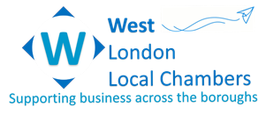 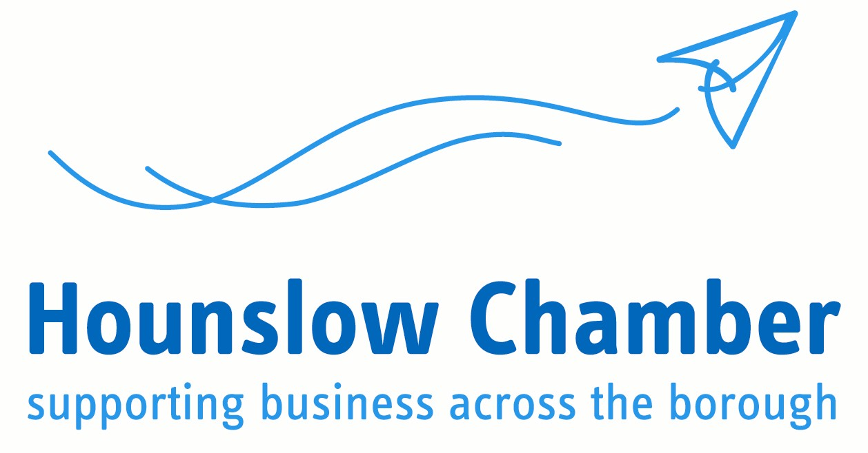
The UK Government’s COVID-19 recovery strategy: Summary of Government Guidance for business
__________________________________________________

The UK Government timetable has published a three-step plan for lifting restrictions. If the Government sees a rise in the infection rate, they may seek to re-impose restrictions in some form. A link to the full document can be found here.

Timescales
  - Step One – Wednesday 13 May
  - Step Two – No earlier than Monday 1 June
  - Step Three – No earlier than 4 July

Step One (Comes into effect on Wednesday 13 May 2020):

- Work
- For the foreseeable future, workers should continue to work from home rather than their normal physical workplace, wherever possible.
- People who are able to work at home make it possible for people who have to attend workplaces in person to do so while minimising the risk of overcrowding on transport and in public places.
- All workers who cannot work from home should travel to work if their workplace is open. Sectors of the economy that are allowed to be open should be open, for example this includes food production, construction, manufacturing, logistics, distribution and scientific research in laboratories. Workplaces that the government is requiring to remain closed include:
  - restaurants and cafes, other than for takeaway
  - pubs, cinemas, theatres and nightclubs
  - clothing and electronics stores; hair, beauty and nail salons; and outdoor and indoor markets (not selling food)
  - libraries, community centres, and youth centres
  - indoor and outdoor leisure facilities such as bowling alleys, gyms, arcades and soft play facilities
  - some communal places within parks, such as playgrounds and outdoor gyms
  - places of worship (except for funerals)
  - hotels, hostels, bed and breakfasts, campsites, caravan parks, and boarding houses for commercial/leisure use, excluding use by those who live in them permanently, those who are unable to return home and critical workers where they need to for work
- Food retailers and food markets, hardware stores, garden centres (from Wednesday 13 May) and certain other retailers can remain open. Other businesses can remain open and their employees can travel to work, where they cannot work from home.
- The Government is amending its guidance to clarify that paid childcare, can take place subject to being able to meet the public health principles.
- Workplaces should follow the new “COVID-19 Secure” guidelines, as set out in the previous chapter, which will be published this week.

- Face-coverings
- Government is now advising that people should aim to wear a face-covering in enclosed spaces where social distancing is not always possible and they come into contact with others that they do not normally meet, for example on public transport or in some shops.
- Homemade cloth face-coverings can help reduce the risk of transmission in some circumstances. Face-coverings should not be used by children under the age of two, or those who may find it difficult to manage them correctly, for example primary age children unassisted, or those with respiratory conditions

- International travel
- All international arrivals will be required to supply their contact and accommodation information. They will also be strongly advised to download and use the NHS contact tracing app.
- All international arrivals not on a short list of exemptions to self-isolate in their accommodation for fourteen days on arrival into the UK.
- Small exemptions to these measures will be in place to provide for continued security of supply into the UK. All journeys within the Common Travel Area (between UK ansd Ireland) will also be exempt from these measures.
- These international travel measures will not come into force on 13 May but will be introduced as soon as possible. Further details, and guidance, will be set out shortly, and the measures and list of exemptions will be kept under regular review.

- Business support
- As the UK adjusts the current restrictions, the Government will also need to wind down the economic support measures while people are eased back to work
- The Government will also need to ensure the UK's supply chains are resilient, ensuring the UK has sufficient access to the essential medicines, PPE, testing equipment, vaccines and treatments it needs, even during times of global shortage.

Step Two (Will come into effect no earlier than Monday 1 June 2020)
- A phased return for early years settings and schools. The Government expects children to be able to return to early years settings, and for Reception, Year 1 and Year 6 to be back in school in smaller sizes, from this point. Secondary schools and further education colleges should also prepare to begin some face to face contact with Year 10 and 12 pupils.
- Opening non-essential retail. Further guidance on the approach expected shortly on the approach taken to phasing, including which businesses will be covered in each phase and timeframes involved. All other sectors that are currently closed, including hospitality and personal care, are not able to re-open at this point because of the higher risk of transmission.
- Re-opening more local public transport in urban areas, subject to strict measures

Step Three (Will come into effect no earlier than 4 July 2020)
- Open at least some of the remaining businesses and premises that have been required to close, including personal care (such as hairdressers and beauty salons), hospitality (such as food service providers, pubs and accommodation), public places (such as places of worship) and leisure facilities (like cinemas). These businesses must meet the COVID-19 Secure guidelines.
- Some venues which are, by design, crowded and where it may prove difficult to enact distancing may still not be able to re-open safely at this point, or may be able to open safely only in part. Nevertheless the Government will wish to open as many businesses and public places as the data and information at the time allows.
- In order to facilitate the fastest possible re-opening of these types of higher-risk businesses and public places, the Government will carefully phase and pilot re-openings to test their ability to adopt the new COVID-19 Secure guidelines.

Guidance for specific types of work
The government have produced eight guides to cover a range of different types of work. The guidance also includes links to other materials – such as risk assessments and a COVID secure declaration that you may wish to display in your workplace. You may need to use more than one of these guides as you think through what you need to do to keep people safe:

- Construction and other outdoor work: for people who work in or run outdoor working environments.
- Factories, plants and warehouses: for people who work in or run factories, plants and warehouses.
- Homes: for people working in, visiting or delivering to home environments as well as their employers.
- Labs and research facilities: for people who work in or run indoor labs and research facilities and similar environments.
- Offices and contact centres: for people who work in or run offices, contact centres and similar indoor environments.
- Restaurants offering takeaway or delivery: for people who work in or run restaurants offering takeaway or delivery services.
- Shops and branches: for people who work in or run shops, branches, stores or similar environments.
- Vehicles: for people who work in or from vehicles, including couriers, mobile workers, lorry drivers, on-site transit and work vehicles, field forces and similar.

Devolved Nations
This guidance applies in England – people in Scotland, Wales and Northern Ireland should follow the specific rules in those parts of the UK. If you live in Scotland, Wales or Northern Ireland additional guidance is available:
- Scotland
- Wales
- Northern Ireland

The Government will work with the devolved administrations to ensure that the changes for step two and beyond are coordinated across the UK – but note there may be circumstances where different measures are lifted at different times due to variance in rate of transmission.

