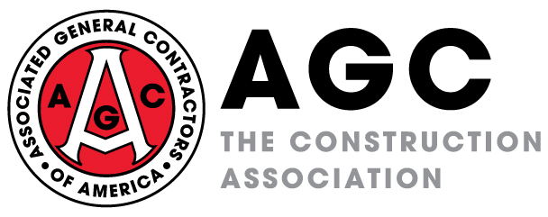

FOR IMMEDIATE RELEASE CONTACT: Brian Turmail

Tuesday, November 7, 2023 (703) 459-0238, brian.turmail@agc.org

CONSTRUCTION ASSOCIATION SUES TO BLOCK BIDEN ADMINISTRATION’S UNLAWFUL EFFORT TO EXPAND THE REACH OF THE DECADES-OLD DAVIS-BACON LAW

Administration Lacks the Legal Authority to Expand Coverage to Areas Specifically Excluded in the Law, or to Retroactively Impose Davis-Bacon Stipulations on Existing Contracts, Group Notes in its Federal Lawsuit

The Associated General Contractors of America filed suit today in federal court to block the Biden Administration’s unlawful effort to expand the reach of a decades-old law that governs wage rates on federally funded construction projects. Association officials noted that the administration lacks the legal authority to expand the law to cover manufacturing facilities miles away from projects, or to retroactively impose the measure on already-executed contracts, among other concerns.

“As an industry that largely pays above existing Davis-Bacon rates, our concerns are with the administration’s unconstitutional exercise of legislative power and not with the wage rate themselves,” said Stephen E. Sandherr, the chief executive officer of the Associated General Contractors of America. “But we are challenging the fact president’s unlawful efforts to expand a construction wage law to cover a wide range of manufacturing and shipping operations.”

The association filed its lawsuit in the U.S. District Court for the Northern District of Texas in response to the U.S. Department of Labor’s final rule proposing significant changes to the Davis-Bacon Act, which was first enacted in 1931. The measure sets construction wage rates for federally funded or assisted public works projects. Among other things, the administration is attempting to expand the construction wage law to cover workers in manufacturing facilities that produce building and infrastructure components, and to cover delivery truck drivers and to retroactively impose the measure on already executed contracts that don’t specifically require Davis-Bacon wage rates.

In its legal filing, the association noted that the Davis-Bacon Act is specifically limited only to “mechanics and laborers employed directly upon the site of the work.” Further, in an amended version of the Act passed in 1935, Congress clarified that the Davis-Bacon law does not apply to materials suppliers. The administration’s attempt to apply the law to materials suppliers operated by contractors or subcontractors represents an illegal attempt by the executive branch to exercise legislative power, the suit notes. Similarly, the rule impermissibly seeks to expand coverage to delivery truck drivers—who are not mechanics or laborers—when they spend an undefined, “not de minimis” amount of time on the jobsite.

The association also challenged the Biden administration rule for asserting that Davis-Bacon rules can be retroactively imposed on qualifying contracts that omitted inclusion of the Davis-Bacon requirements. They noted the Davis Bacon Act expressly requires that public contracts contain the Davis-Bacon stipulations for them to be applied. The lawsuit notes that the administration lacks the legal authority, or legal precedent, to retroactively impose Davis-Bacon stipulations on executed contracts that omitted them when signed.

The association is seeking to have the court order the administration to roll back its efforts to expand Davis-Bacon requirements to categories of work that were excluded in the initial legislation. Likewise, the association is urging the court to block the administration from retroactively imposing Davis Bacon requirements on executed contracts that did not include the provisions. However, the association is not challenging the Biden Administration’s efforts to revert to an earlier process for determining the prevailing wage rates for federally funded construction projects.

Click here for a copy of the association’s petition to the court.

###

