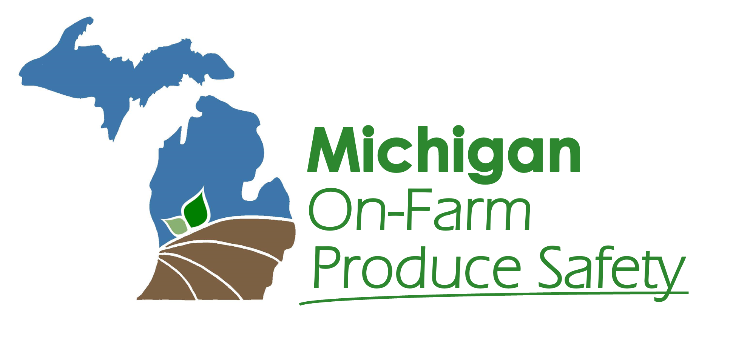

Agricultural Water Assessment
Template Updated July 2025

A Note To Farmers:
This Agricultural Water Assessment template is designed to serve as a starting point for meeting the FSMA PSR Water Rule Requirements. The sections and information in this template are meant to be edited to reflect your farm’s unique circumstances. Italicized text throughout the template provides directions to the farm and is intended to be removed after completion of the assessment.

Contents:
Water Sources On-Farm 2
Water Uses On-Farm 2
Water System Inspections 3
Water System/Source Protection 4
Water Testing 4
Water Treatment 5
Environmental Assessment 5
Crop Characteristics Assessment 5
Mitigation & Corrective Actions 6
Summary 7

Step 1: Determine if you need an Ag Water Assessment

Agricultural Water Uses (pre-harvest)
Pre-harvest Agricultural Water Sources (Check all water sources used on produce pre-harvest)
- Municipal Water
- Ground Water (well)
- Surface Water (river, lake, stream, pond, etc.)
- Other: ____________________________________
Pre-harvest Agricultural Water Uses (Check all water uses that apply to your farm)
- Irrigation
- Fertigation
- Crop Sprays
- Cooling
- Frost Protection
- Dust Abatement
- Hand washing
- Cleaning & Sanitizing Food-Contact Surfaces
- Other: ____________________________________

Will any of the above water sources and uses be used on produce covered by the Produce Safety Rule?
- No —> You do not need an Ag Water Assessment.
- Yes —> Continue to the next question.

Is the water used on covered produce intended to, or likely to, touch the harvestable part of the crop?
- No —> You do not need an Ag Water Assessment.
- Yes —> Continue to Step 2 of the assessment.

Step 2: Ag Water Asessment

Water System/Source Protection
The degree of protection of the water system from potential contamination can be described as:

- Closed delivery system: water is never exposed to the environment from the water source to the point of use.
- Open delivery system: water is exposed to the environment at any point from the water source to the point of use. (i.e., ponds, reservoirs, canals, uncovered water tanks, etc.)
If there are any concerns about the degree of protection or control over the water system, please describe the concerns:

General time interval between last direct application and harvest: (i.e., one week before harvest, day of harvest, etc. If there are typical exceptions, include them.)

Environmental Assessment
Environmental Conditions Assessment: (i.e., conditions that could impact the water quality of the farm’s water system(s) as they pertain to this farm, including frequency of heavy rain, hail, or extreme weather events, air temperatures, sun (UV) exposure, etc.)

Crop Characteristics Assessment
Crop Characteristics Assessment: (List specific crop characteristics that may increase food safety risk, i.e., zucchini’s soft skin has higher risk for surface wounds; textured surfaces of strawberries and cantaloupe can trap bacteria; tomatoes and other soft fruits have a higher risk for infiltration of bacteria from contaminated water; similarities to known commodity-related outbreaks, etc.)

Mitigation & Corrective Actions
Describe any mitigation measures and/or corrective actions needed, following the FSMA Final Rule on Pre-Harvest Agricultural Water:

Corrective Actions:
Immediately discontinue use if pre-harvest agricultural water is not safe or of inadequate sanitary quality and implement corrective actions before resuming use.
- Identify conditions contributing to contamination and make necessary changes to the water system based on the inspection findings
- Clean any necessary equipment, including the water distribution system, that may have been contaminated
- Treat the water to Produce Safety Rule (PSR) standards to ensure it is safe and sanitary
- Re-inspect water systems and document whether the corrective actions were effective
- If mitigation measures are needed, they should be implemented to reduce the potential for contamination from the water
- Other: ____________________________________

Mitigation Measures:
If there are conditions reasonably likely to introduce known or reasonably foreseeable hazards from animal activity (poop-related), mitigation measures must be taken within the same growing season.
If there are conditions reasonably likely to introduce known or reasonably foreseeable hazards unrelated to animal activity (not poop-related), mitigation measures must be taken within one year.
- Modify water systems, such as making repairs, improving sanitation practices, installing a berm or windbreak, or other changes to reduce contamination
- Increase the time between the last irrigation and harvest to allow for microbial die-off
- Increase the time between harvest and the end of storage/sale to allow for microbial die-off
- Change the method of water use to minimize direct contact with produce
- Test the water to Produce Safety Rule (PSR) standards
- Treat the water to Produce Safety Rule (PSR) standards to ensure it is safe and sanitary
- Re-inspect water systems to ensure mitigation measures were effective
- Other: ____________________________________

Water Testing
Provide testing results or other relevant factors that could affect this agricultural water assessment. This includes water tests for water systems used for both pre-harvest and post-harvest water. Water used during and after harvest MUST be tested annually and found to have no detectable generic E. coli per 100 mL sample. Growers with access to a municipal water source are not required to test their water, but must obtain a copy of the municipality’s water quality report or a Certificate of Conformance with the EPA Safe Drinking Water Act.
Testing Frequency (list testing frequency/schedule for each water source tested. i.e., “Once every spring” or “Four times each year between April and August)

Laboratory (i.e., “Marquette Water Filtration Plant” A map of accredited testing laboratories can assist in finding a lab near you.)

Testing Method (list all testing methods used, i.e., “Test Method 9223 B.”)

Water Treatment
Surface water MUST be treated if it is used during or after harvest!
Growers may also treat their water sources based on circumstances, such as water test results indicating contamination or reusing water in recirculating systems.
Water Source

Water Treatment Method (i.e., chlorinating, ozone, UV lights, etc.)

Verification (i.e., water testing/verification of pathogen die-off)

Summary
Provide a summary of this agricultural water assessment, including a determination about whether corrective actions or mitigation actions are needed for each water system. The summary should include mitigation measures to address known or foreseeable hazards in the agricultural water system(s) associated with all animal activity.

Review by Farm Supervisor
A farm supervisor must review, date, and sign this assessment and any mitigation or corrective action efforts before harvest.
Name | Signature | Date

