Pediatric Cooking Classes

**FREE Pediatric Healthy Cooking Classes at BMC**

***Family Fun with Food***

*First Wednesday of every month from 5:00-6:00pm*

*&*

***SUPER Kids and Teens***

*(Shape Up and Eat Right)*

*Super Kids (ages 6-12) 2nd Monday every month from 5:00-6:00pm*

*Super Teens (ages 13-17) Last Monday every month from 5:00-6:00pm*

**Hands-on cooking classes taught by a Registered Dietitian.**

**Delicious food the whole family will love!**

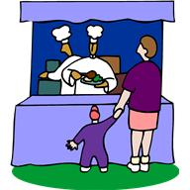

**Learn to Cook!**

**Bring the Kids!**

No reservations necessary

***BMC Demonstration Kitchen***

***Boston Medical Center, 850 Harrison Ave, Yawkey Building 2nd Floor***

**For complete class schedules and recipes go to**

[**www.bmc.org/programs/food-demonstration-kitchen**](http://www.bmc.org/programs/food-demonstration-kitchen)

**617-414-3840**